[](http://www.veratics.com)

**Maternity Tracker – FTL Installation Guide**

**Version 1.0**

### ABSTRACT

This document describes the steps for installing Maternity Tracker code within VistA FTL.

It is meant to be a live document; therefore, it will be updated frequently.

### REVISION HISTORY

|  |  |  |  |
| --- | --- | --- | --- |
| Version | Date | Modified By | Description |
| 1.0 | 10/04/2017 | Alina Frey | Initial Release |
| 1.1 | 10/06/2017 | Josh Stephens | Added steps for Dashboard deployment to IIS |
|  |  |  |  |
|  |  |  |  |
|  |  |  |  |

Table of Contents

ABSTRACT 2

REVISION HISTORY 2

1 Paths for consideration 5

1.1 Paths to consider on FTL machine 5

1.2 Paths to consider on your local machine 5

2 Required Machines with Admin credentials 6

3 Maternity Tracker Dashboard Local Setup 7

3.1 Cloning Maternity Tracker repository on the local machine 7

3.2 Installing Visual Studio 8

3.3 Adding Maternity Tracker project to Visual Studio 9

3.4 Building and Running the Maternity Tracker Project 15

4 Installing Maternity Tracker packages into VistA 23

4.1 Copy Maternity Tracker kid files into VistA 23

4.2 Load Maternity Tracker kid files into VistA 25

4.3 Install Maternity Tracker kid files into VistA 27

5 Verification that the TIU Document Titles Were Extracted 40

6 Schedule the Task to PUSH Discreet Data 42

7 Set Trigger Parameters 44

7.1 Configure Triggering 44

7.2 Configure Consults 44

7.3 Configure Labs 45

7.4 Configure Problems 49

8 Users Setup 51

8.1 Create Users 51

8.2 Add Verify Code for the created users 52

8.3 Allocate keys to the new users 54

8.4 Add Primary and Secondary menus to the new users 57

8.4.1. Modify the web.config 59

8.5 Assign SECURITY KEY 59

8.6 Assign CPRS TAB 62

8.7 Assign Electronic Signature 63

9 Configure IIS Server 65

10 Deploy Maternity Tracker Dashboard to IIS 73

11 Login using the created users 79

12 Resources 80

13 Appendix 81

13.1 Commands frequently used 81

13.2 VistA Text Mode Conventions 81

1. Paths for consideration

The following are a few paths that will be used throughout the installation document:

* 1. Paths to consider on FTL machine

1. Path to Maternity Tracker folder:

**<FTL_path_to_MT>: /home/<FTL_username>/MTkids**

1. Path to kids **builds** folder:

**<FTL_path_to_builds>: <FTL_path_to_MT>/builds**

1. Path to kids **TITLES** folder:

**<FTL_path_to_TITLES>: <FTL_path_to_MT>/TITLES**

* 1. Paths to consider on your local machine

1. Local path to Maternity Tracker folder:

**<LOCAL_path_to_MT>:** C:\Users\<LOCAL_user_name>\Projects\Maternity-Tracker

1. Local path to kids **builds** folder:

**<LOCAL_path_to_builds>: <LOCAL_path_to_MT>/builds**

1. Local path to kids **TITLES** folder:

**<LOCAL_path_to_TITLES>: <LOCAL_path_to_MT>/TITLES**

1. Required Machines with Admin credentials
2. Linux hosted VistA instance running on Cache
   1. Hosts the Maternity Tracker VistA package KIDS builds
3. Windows Server 2012 hosting Internet Information Servers (IIS) v8.5 with Web Deployment Package installed.
   1. Hosts the Maternity Tracker Dashboard web server
4. Windows Machine running Microsoft Visual Studio
   1. Machine used for development and publishing the changes.
5. Maternity Tracker Dashboard Local Setup
   1. Cloning Maternity Tracker repository on the local machine

This step is necessary to get hold of kid files necessary in the next chapter.

1. If the Veratics Maternity Tracker project does not exist, create Maternity Tracker Repo on GitHub:
   1. Login to Veratics’ GitHub: <https://github.com/veratics/>
   2. Fork <https://github.com/VHAINNOVATIONS/Maternity-Tracker>
   3. This will create this repo: <https://github.com/Veratics/Maternity-Tracker>
2. Download and install SourceTree for Windows:
   1. <https://www.sourcetreeapp.com/>
3. Clone Maternity Tracker repo in SourceTree:
   1. File >> Clone/New.
   2. Fill in the required fields:
      1. Source Path: <https://github.com/Veratics/Maternity-Tracker>
      2. Destination Path: **<LOCAL_path_to_MT>**
      3. Name: Maternity-Tracker

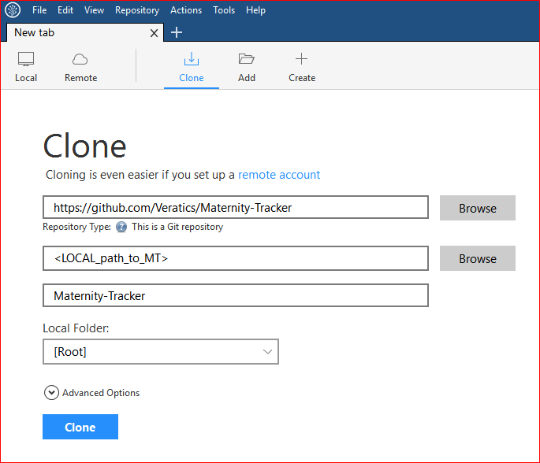

* 1. Installing Visual Studio

1. Download and Install Visual Studio Professional 2017:
   1. <https://www.visualstudio.com/vs/professional/>
2. Modify the install to add C# Template (only if Visual Studio is missing the C# template):
   1. Go to **Start >> All Programs >> “Visual Studio 2017” >> “Visual Studio Installer”.** Now, click Visual Studio Installer.
   2. Click **Yes** button and the Visual Studio Installer will open.
   3. There are three options we can see in the installer: Modify, Repair, Uninstall
   4. Choose **Modify** option.

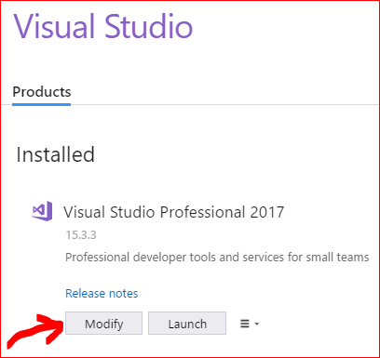

* 1. Add ".NET desktop development" package:

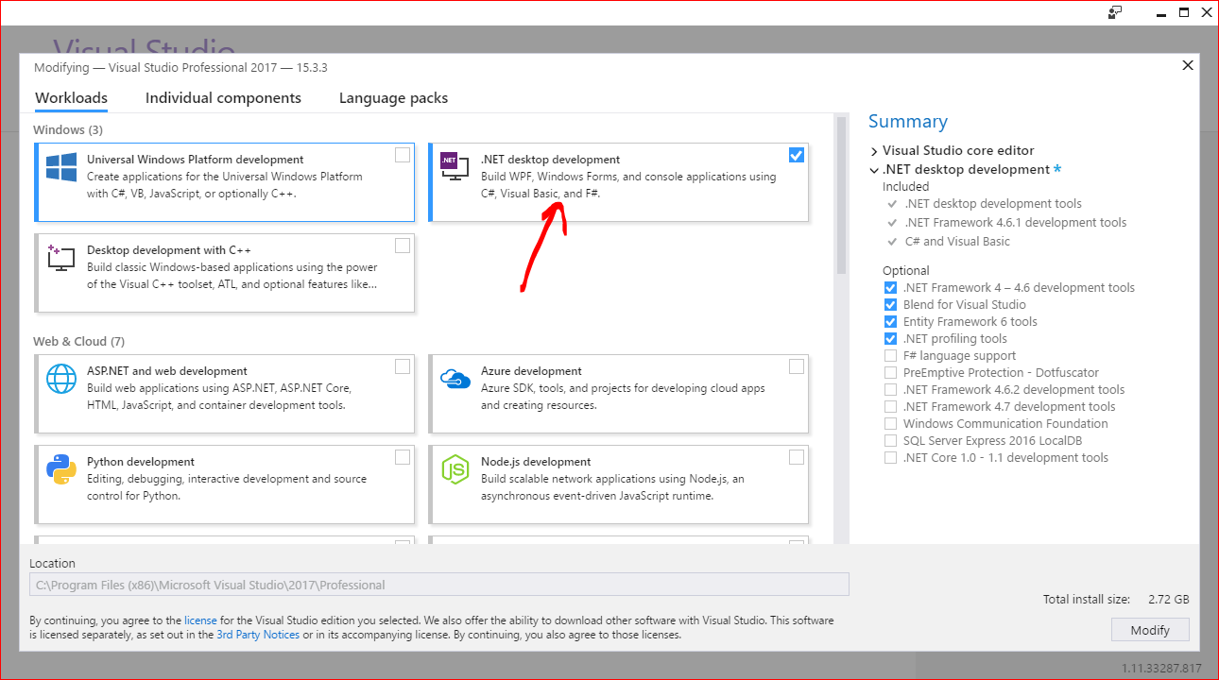

* 1. Click **Modify** button.
  2. Adding Maternity Tracker project to Visual Studio

1. File >> Open >> Open form Source Control. This opens the Team Explorer Pane. At the top, click on Connect button (the green plug), and click on Add under the Local Git Repositories section. Add the location of the repositories.

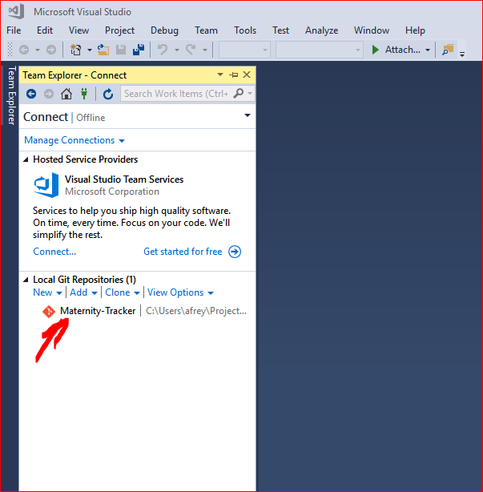

1. Double click on the **Maternity-Tracker** repo. This opens the Team Explorer panel with the solutions of the project.

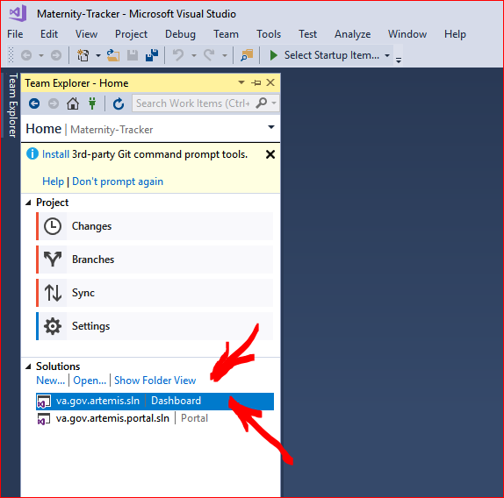

1. Double click on the first solution: **va.gov.artemis.sln.**
2. It will ask to install missing features. Click **Install** button.

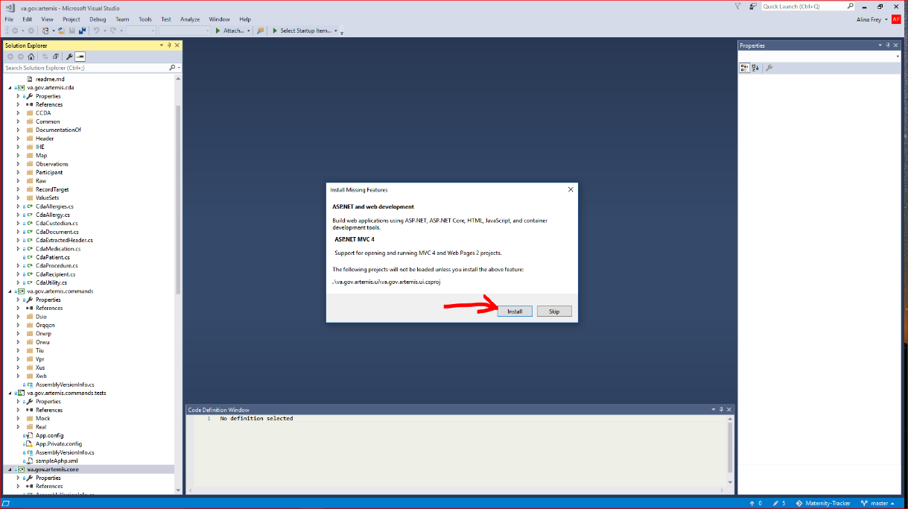n

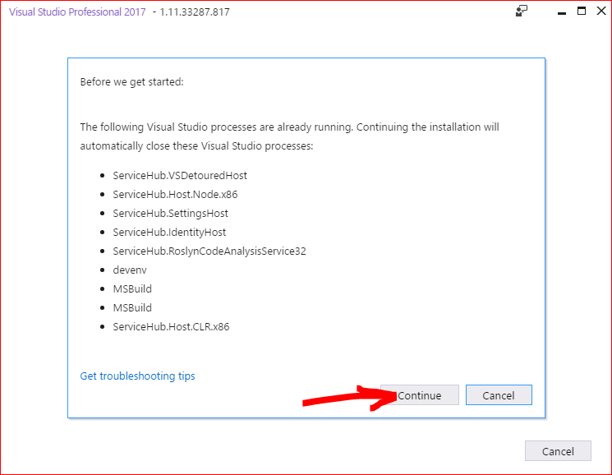

1. To install Git command prompt tools, click on the message at the top of the Team Explorer panel:

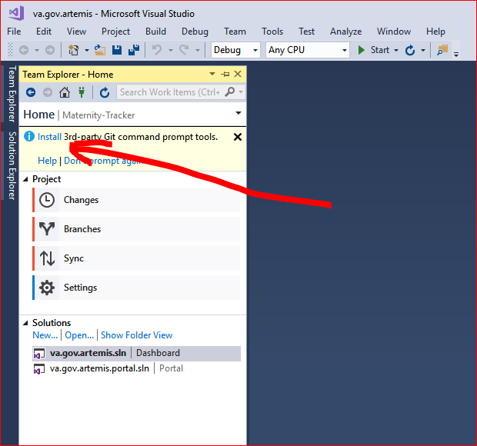

1. To switch to the Folder View, click on **Show Folder View** at the top of the Solutions section in the Team Explorer panel.
2. There are two solutions to the project, which can be seen from the Solution Explorer View (Folder View) or the Team Explorer View:

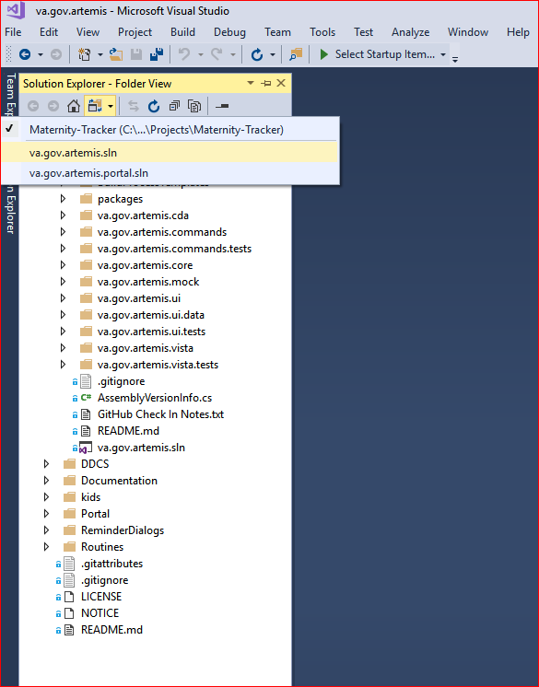

1. Restore NuGet packages before build:
   1. Right click on the solution **va.gov.artemis.sln** in the **Solution Explorer (Folder View)**

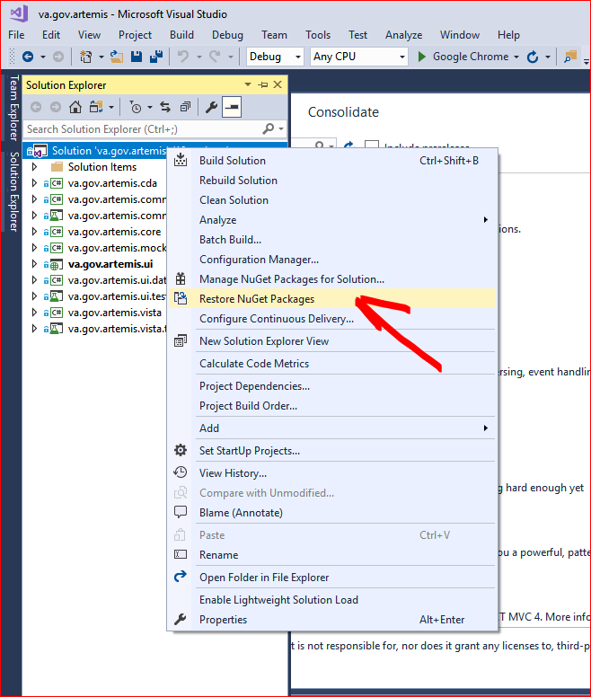

* 1. The folder 'packages' should be added to the Dashboard folder of the project:

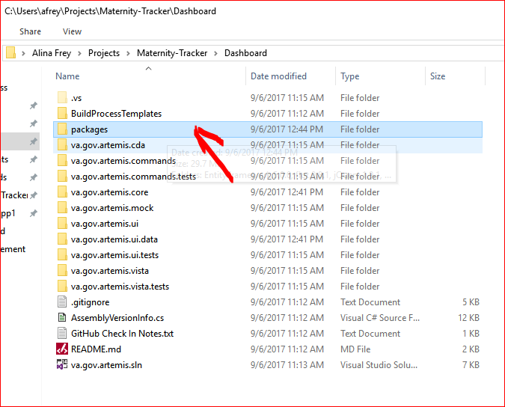

* 1. Building and Running the Maternity Tracker Project

1. Add the required resources:
   1. Expand the package **va.gov.artemis.ui**
   2. Right click on the References folder >> Add Reference

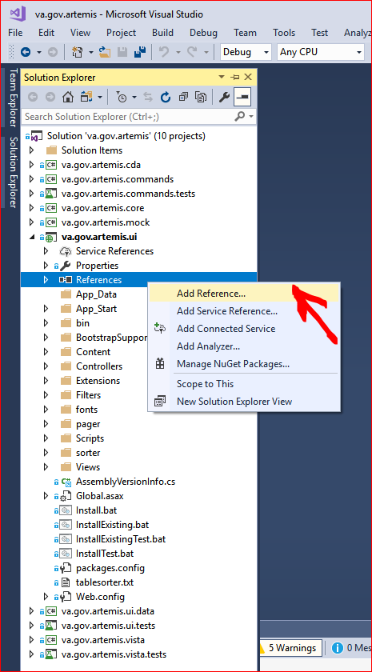

* 1. Browse to, and Add the following file, then click Ok:

**C:\Users\<your-user-name>\Projects\Maternity-Tracker\Dashboard\packages\Microsoft.AspNet.Mvc.4.0.20710.0\lib\net40\System.Web.Mvc.dll**

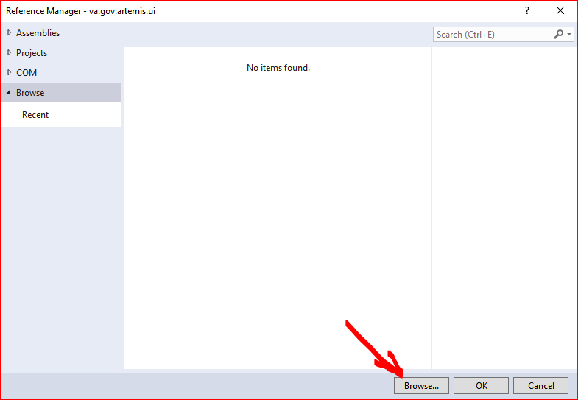

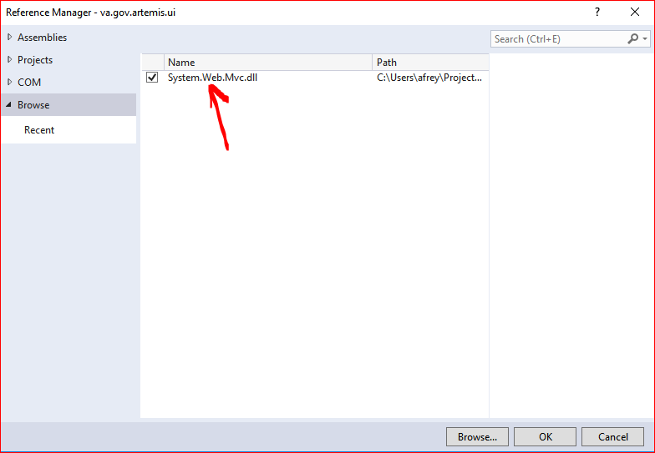

1. Build the project:

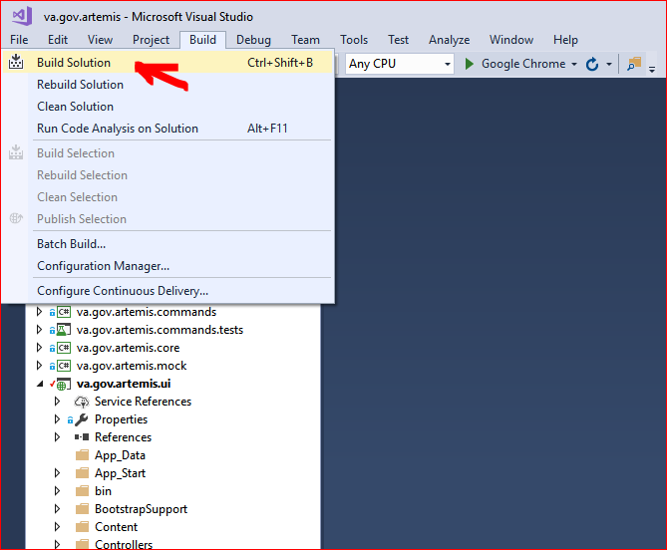

1. In the output panel you should see the build messages: errors or warnings

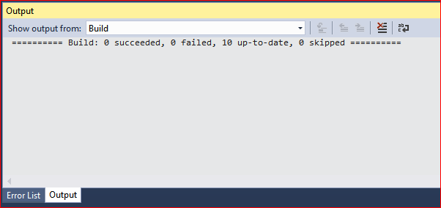

1. There are a couple of warnings that show up in the console. The one on top related to Newtonsoft.Json needs to be addressed. For now, just double click on the warning and accept by clicking **OK** button. That solves the problem temporarily.

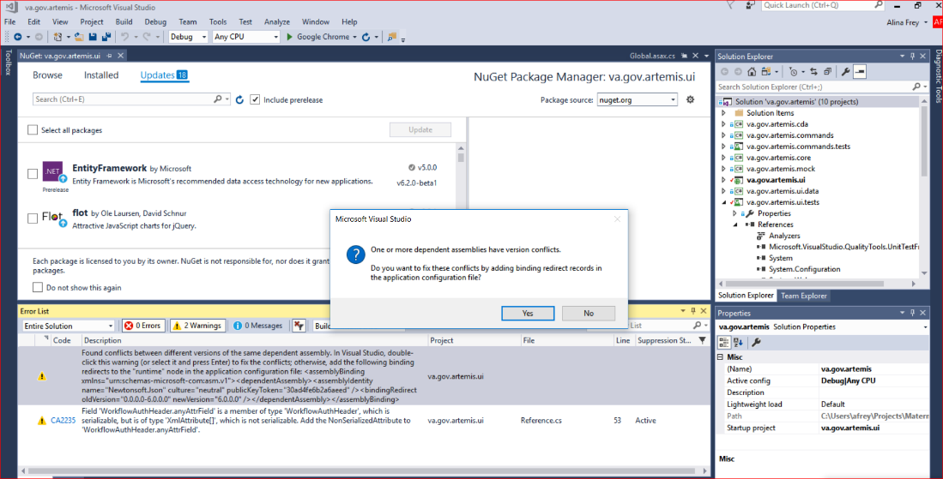

1. Run the Application.

Note: This step is not necessary for publishing the build to the FTL site. But it is good for verification and testing on the local machine before deploying on the FTL site.

* 1. Right click on the package **va.gov.artemis.ui >> Debug >> Start new Instance.**

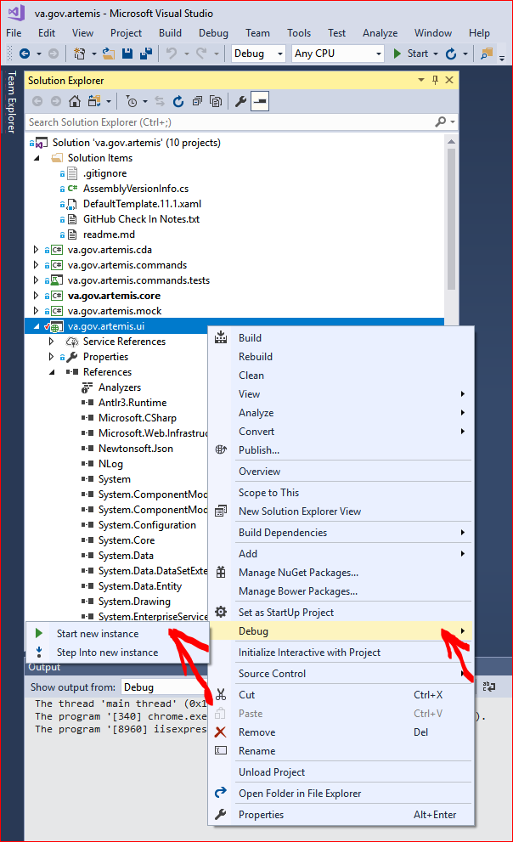

* 1. You will get a warning regarding the Self-Signed certificate. Select the checkbox for 'Do not ask me again', and the select **Ok**.

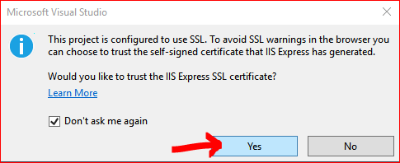

* 1. Select **Yes** button at the next warning, to install the certificate:

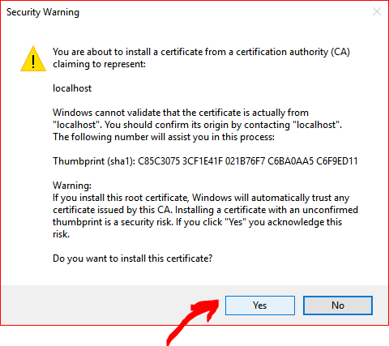

* 1. If your default web browser is Chrome, you may see this message:

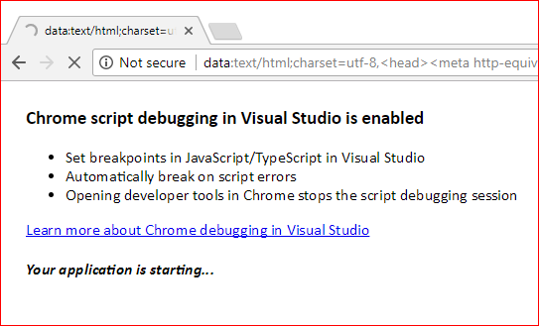

* 1. After everything loads, you should be able to see the Dashboard:

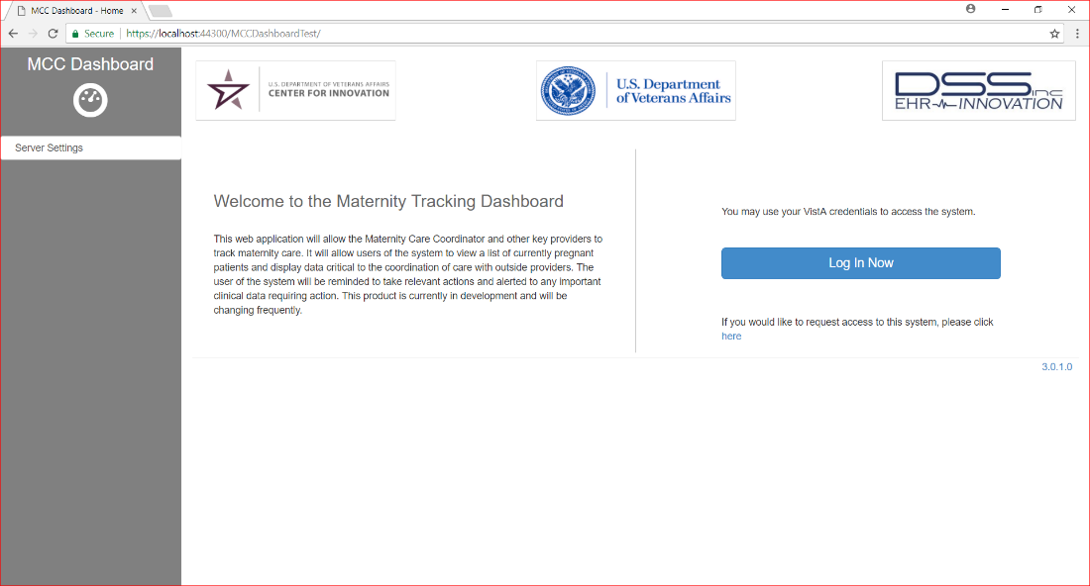

1. Installing Maternity Tracker packages into VistA
   1. Copy Maternity Tracker kid files into VistA
2. Login to FTL machine using Putty:

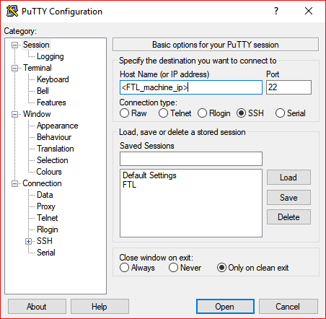

1. This opens Putty command prompt.
2. Enter **<FTL_username>** and **<FTL_password>**
3. On FTL machine, using the same Putty command window, create a new folder structure where the kid files (from your local machine) will be copied to**:**

$ cd ~

$ mkdir MTkids

$ cd MTkids

$ mkdir builds

$ mkdir TITLES

$ ls

builds TITLES

**NOTE**: The **TITLES** folder needs to be under the same parent directory as the **builds** folder. This is necessary when loading and installing the kid files. The installation will not complete correctly if the TITLES are not under the same root directory.

1. Copy the **build** kid files from your local machine to the FTL machine using **Bash command**:

$ pscp **<LOCAL_path_to_builds>**/* **<FTL_username>**@**<FTL_machine_ip>**:**<FTL_path_to_builds>**

**<FTL_username>**@**<FTL_machine_ip>**'s password: **<FTL_password>**

WEBM_1.KID | 670 kB | 670.8 kB/s | ETA: 00:00:00 | 100%

WEBM_2.KID | 984 kB | 984.2 kB/s | ETA: 00:00:00 | 100%

MATERNITY_TRACKER_3.KID | 982 kB | 982.0 kB/s | ETA: 00:00:00 | 100%

1. Copy the **TITLES** kid files from your local machine to the FTL machine using **Bash command:**

$ pscp **<LOCAL_path_to_TITLES>**/* **<FTL_username>**@**<FTL_machine_ip>**:**<FTL_path_to_TITLES>**

**<FTL_username>**@**<FTL_machine_ip>**'s password: **<FTL_password>**

WEBM_TIU_TITLE_01.TXT | 1 kB | 1.4 kB/s | ETA: 00:00:00 | 100%

WEBM_TIU_TITLE_02.TXT | 1 kB | 1.4 kB/s | ETA: 00:00:00 | 100%

WEBM_TIU_TITLE_03.TXT | 1 kB | 1.4 kB/s | ETA: 00:00:00 | 100%

WEBM_TIU_TITLE_04.TXT | 1 kB | 1.5 kB/s | ETA: 00:00:00 | 100%

WEBM_TIU_TITLE_05.TXT | 1 kB | 1.4 kB/s | ETA: 00:00:00 | 100%

WEBM_TIU_TITLE_06.TXT | 1 kB | 1.4 kB/s | ETA: 00:00:00 | 100%

WEBM_TIU_TITLE_07.TXT | 1 kB | 1.5 kB/s | ETA: 00:00:00 | 100%

WEBM_TIU_TITLE_08.TXT | 1 kB | 1.5 kB/s | ETA: 00:00:00 | 100%

WEBM_TIU_TITLE_09.TXT | 1 kB | 1.5 kB/s | ETA: 00:00:00 | 100%

WEBM_TIU_TITLE_10.TXT | 1 kB | 1.5 kB/s | ETA: 00:00:00 | 100%

WEBM_TIU_TITLE_11.TXT | 1 kB | 1.5 kB/s | ETA: 00:00:00 | 100%

WEBM_TIU_TITLE_12.TXT | 1 kB | 1.5 kB/s | ETA: 00:00:00 | 100%

WEBM_TIU_TITLE_13.TXT | 1 kB | 1.5 kB/s | ETA: 00:00:00 | 100%

WEBM_TIU_TITLE_14.TXT | 1 kB | 1.5 kB/s | ETA: 00:00:00 | 100%

WEBM_TIU_TITLE_15.TXT | 1 kB | 1.5 kB/s | ETA: 00:00:00 | 100%

WEBM_TIU_TITLE_16.TXT | 1 kB | 1.5 kB/s | ETA: 00:00:00 | 100%

WEBM_TIU_TITLE_17.TXT | 1 kB | 1.6 kB/s | ETA: 00:00:00 | 100%

WEBM_TIU_TITLE_18.TXT | 1 kB | 1.6 kB/s | ETA: 00:00:00 | 100%

WEBM_TIU_TITLE_19.TXT | 1 kB | 1.6 kB/s | ETA: 00:00:00 | 100%

WEBM_TIU_TITLE_20.TXT | 1 kB | 1.4 kB/s | ETA: 00:00:00 | 100%

* 1. Load Maternity Tracker kid files into VistA

1. Login to FTL machine using Putty again (same as step #1) and open a VistA Cache instance:

$ cd /

$ sudo csession cache -U GOLD

Node: ip-10-99-193-70.ec2.internal, Instance: CACHE

GOLD>

1. Load the kid files into this VistA instance. You will have to provide the path to the new location **<FTL_path_to_builds>/<filename>** for all 3 kids files: WEBM_1.KID, WEBM_2.KID, MATERNITY_TRACKER_3.KID. This step seems to fail if the path given to the file is too long. You may have to copy one or more files into a folder that has a shorter path, and provide that path to have it loaded.

VISTA>**S DUZ=1**

VISTA>**D ^XUP**

Setting up programmer environment

This is a TEST account.

Terminal Type set to: C-VT220

Select OPTION NAME: <**KERNEL**>

1 KERNEL GUI ALERTS XQAL GUI ALERTS Kernel GUI Alerts

2 KERNEL INSTALLATION & DISTRIBU XPD MAIN Kernel Installation & Distribution System

3 KERNEL MANAGEMENT MENU XUKERNEL Kernel Management Menu

4 KERNEL NEW FEATURES HELP XUVERSIONEW-HELP Kernel New Features Help

5 KERNEL PKI PARAMETER EDIT XUSSPKI EDIT Kernel PKI Parameter Edit

Press <Enter> to see more, '^' to exit this list, OR

CHOOSE 1-5: **<2>** XPD MAIN Kernel Installation & Distribution System

Edits and Distribution ...

Utilities ...

Installation ...

Patch Monitor Main Menu ...

Select Kernel Installation & Distribution System <TEST ACCOUNT> Option: <**Installation**>

1 Load a Distribution

2 Verify Checksums in Transport Global

3 Print Transport Global

4 Compare Transport Global to Current System

5 Backup a Transport Global

6 Install Package(s)

Restart Install of Package(s)

Unload a Distribution

1. Load **WEBM_1.KID**:

Select Installation <TEST ACCOUNT> Option: <**1**> Load a Distribution

Enter a Host File: **<FTL_path_to_builds>/WEBM_1.KID**

KIDS Distribution saved on Apr 10, 2015@12:06:59

Comment: WEBM 1.0

This Distribution contains Transport Globals for the following Package(s):

WEBM 1.0

Distribution OK!

Want to Continue with Load? YES// **yes** YES

Loading Distribution...

WEBM 1.0

Use INSTALL NAME: WEBM 1.0 to install this Distribution.

1 Load a Distribution

2 Verify Checksums in Transport Global

3 Print Transport Global

4 Compare Transport Global to Current System

5 Backup a Transport Global

6 Install Package(s)

Restart Install of Package(s)

Unload a Distribution

1. Load **WEBM_2.KID**:

Select Installation <TEST ACCOUNT> Option: **1** Load a Distribution

Enter a Host File: **<FTL_path_to_builds>/WEBM_2.KID**

KIDS Distribution saved on Sep 19, 2016@12:02:45

Comment: WEBM 2.0

This Distribution contains Transport Globals for the following Package(s):

WEBM 2.0

Distribution OK!

Want to Continue with Load? YES// **yes** YES

Loading Distribution...

WEBM 2.0

Use INSTALL NAME: WEBM 2.0 to install this Distribution.

1 Load a Distribution

2 Verify Checksums in Transport Global

3 Print Transport Global

4 Compare Transport Global to Current System

5 Backup a Transport Global

6 Install Package(s)

Restart Install of Package(s)

Unload a Distribution

1. Load **MATERNITY_TRACKER_3.KID**:

Select Installation <TEST ACCOUNT> Option: **1** Load a Distribution

Enter a Host File: **<FTL_path_to_builds>/MATERNITY_TRACKER_3.KID**

This Distribution contains Transport Globals for the following Package(s):

Build MATERNITY TRACKER 3.0 has been loaded before, here is when:

MATERNITY TRACKER 3.0 Install Completed

was loaded on Sep 21, 2017@16:48:54

OK to continue with Load? NO// **YES**

Distribution OK!

Want to Continue with Load? YES// **YES**

Loading Distribution...

MATERNITY TRACKER 3.0

Use INSTALL NAME: MATERNITY TRACKER 3.0 to install this Distribution.

1 Load a Distribution

2 Verify Checksums in Transport Global

3 Print Transport Global

4 Compare Transport Global to Current System

5 Backup a Transport Global

6 Install Package(s)

Restart Install of Package(s)

Unload a Distribution

Select Installation <TEST ACCOUNT> Option:

* 1. Install Maternity Tracker kid files into VistA

Continue from the above menu.

**NOTE**: The WEBM 2.0 and Maternity Tracker 3.0 installations will prompt you for the location of the Titles files found under **<FTL_path_to_TITLES>**, so the **TITLES** folder needs to be under the same parent directory as the **builds** folder.

1. Install **WEBM 1.0**:

Select Installation <TEST ACCOUNT> Option: **install** Package(s)

Select INSTALL NAME: **d**

1 WEBM 1.0 Loaded from Distribution 9/25/17@15:25:25

=> WEBM 1.0 ;Created on Apr 10, 2015@12:06:59

2 WEBM 2.0 Loaded from Distribution 9/25/17@15:27:47

=> WEBM 2.0 ;Created on Sep 19, 2016@12:02:45

CHOOSE 1-2: **1** WEBM 1.0 Loaded from Distribution 9/25/17@15:25:25

=> WEBM 1.0 ;Created on Apr 10, 2015@12:06:59

This Distribution was loaded on Sep 25, 2017@15:25:25 with header of

WEBM 1.0 ;Created on Apr 10, 2015@12:06:59

It consisted of the following Install(s):

WEBM 1.0

Checking Install for Package WEBM 1.0

Install Questions for WEBM 1.0

Incoming Files:

19641 WEBM PATIENT

Note: You already have the 'WEBM PATIENT' File.

19641.01 WEBM MENSTRUAL HISTORY

Note: You already have the 'WEBM MENSTRUAL HISTORY' File.

19641.03 WEBM EDD HISTORY

Note: You already have the 'WEBM EDD HISTORY' File.

19641.1 WEBM OUTSIDE ENTITIES

*BUT YOU ALREADY HAVE 'WEBM EXTERNAL ENTITIES' AS FILE #19641.1!

Shall I write over your WEBM EXTERNAL ENTITIES File? YES// y YES

19641.11 WEBM PERSON

Note: You already have the 'WEBM PERSON' File.

19641.112 WEBM FETUS/BABY

Note: You already have the 'WEBM FETUS/BABY' File.

19641.12 WEBM OBSERVATIONS

Note: You already have the 'WEBM OBSERVATIONS' File.

19641.122 WEBM OBSERVATION CATEGORY

*BUT YOU ALREADY HAVE 'WEBM DDCS OBSERVATION CONFIG' AS FILE #19641.122!

Shall I write over your WEBM DDCS OBSERVATION CONFIG File? YES// y YES

19641.123 WEBM OBSERVATION PUSH (including data)

Note: You already have the 'WEBM OBSERVATION PUSH' File.

I will REPLACE your data with mine.

19641.124 WEBM PUSH HISTORY

*BUT YOU ALREADY HAVE 'WEBM DDCS PUSH HISTORY' AS FILE #19641.124!

Shall I write over your WEBM DDCS PUSH HISTORY File? YES// y YES

19641.13 WEBM PREGNANCY HISTORY

Note: You already have the 'WEBM PREGNANCY HISTORY' File.

19641.2 WEBM TRACKING HISTORY

Note: You already have the 'WEBM TRACKING HISTORY' File.

19641.22 WEBM TRACKING SOURCE (including data)

Note: You already have the 'WEBM TRACKING SOURCE' File.

I will MERGE your data with mine.

19641.23 WEBM TRACKING REASON (including data)

Note: You already have the 'WEBM TRACKING REASON' File.

I will MERGE your data with mine.

19641.31 WEBM TRIGGER PROBLEM (including data)

Note: You already have the 'WEBM TRIGGER PROBLEM' File.

I will REPLACE your data with mine.

19641.33 WEBM TRIGGER LAB TEST (including data)

*BUT YOU ALREADY HAVE 'WEBM TRIGGER LABS' AS FILE #19641.33!

Shall I write over your WEBM TRIGGER LABS File? YES// y YES

I will REPLACE your data with mine.

19641.35 WEBM TRIGGER CONSULT (including data)

Note: You already have the 'WEBM TRIGGER CONSULT' File.

I will REPLACE your data with mine.

19641.4 WEBM NOTE CONTROL

*BUT YOU ALREADY HAVE 'WEBM DDCS CONTROL' AS FILE #19641.4!

Shall I write over your WEBM DDCS CONTROL File? YES// y YES

19641.401 WEBM REPORT ITEMS (including data)

*BUT YOU ALREADY HAVE 'WEBM DDCS REPORT ITEMS' AS FILE #19641.401!

Shall I write over your WEBM DDCS REPORT ITEMS File? YES// y YES

I will REPLACE your data with mine.

19641.402 WEBM REMINDER ELEMENTS

Note: You already have the 'WEBM REMINDER ELEMENTS' File.

19641.41 WEBM NOTE DATA

*BUT YOU ALREADY HAVE 'WEBM DDCS DATA' AS FILE #19641.41!

Shall I write over your WEBM DDCS DATA File? YES// y YES

19641.45 WEBM NOTE ELEMENT

*BUT YOU ALREADY HAVE 'WEBM DDCS ELEMENT' AS FILE #19641.45!

Shall I write over your WEBM DDCS ELEMENT File? YES// y YES

19641.48 WEBM OCNT CONFIGURATION (including data)

I will REPLACE your data with mine.

19641.49 WEBM OCNT DIALOGS (including data)

*BUT YOU ALREADY HAVE 'WEBM DDCS DIALOGS' AS FILE #19641.49!

Shall I write over your WEBM DDCS DIALOGS File? YES// y YES

I will REPLACE your data with mine.

19641.492 WEBM OCNT ACTION (including data)

*BUT YOU ALREADY HAVE 'WEBM DDCS PARAMETER' AS FILE #19641.492!

Shall I write over your WEBM DDCS PARAMETER File? YES// y YES

I will REPLACE your data with mine.

19641.4941WEBM OCNT SHARED DATA

*BUT YOU ALREADY HAVE 'WEBM DDCS SHARED DATA' AS FILE #19641.4941!

Shall I write over your WEBM DDCS SHARED DATA File? YES// y YES

19641.5 WEBM TITLE CONFIGURATION

Note: You already have the 'WEBM TITLE CONFIGURATION' File.

19641.6 WEBM IHE DOCUMENT

Note: You already have the 'WEBM IHE DOCUMENT' File.

19641.61 WEBM IHE DOCUMENT TYPE (including data)

Note: You already have the 'WEBM IHE DOCUMENT TYPE' File.

I will REPLACE your data with mine.

19641.7 WEBM MCC CHECKLIST

Note: You already have the 'WEBM MCC CHECKLIST' File.

19641.71 WEBM MCC CHECKLIST TYPE (including data)

Note: You already have the 'WEBM MCC CHECKLIST TYPE' File.

I will REPLACE your data with mine.

19641.72 WEBM MCC CHECKLIST DCT (including data)

Note: You already have the 'WEBM MCC CHECKLIST DCT' File.

I will MERGE your data with mine.

19641.73 WEBM MCC CHECKLIST CAT (including data)

Note: You already have the 'WEBM MCC CHECKLIST CAT' File.

I will MERGE your data with mine.

19641.74 WEBM MCC CHECKLIST COMSTAT (including data)

Note: You already have the 'WEBM MCC CHECKLIST COMSTAT' File.

I will MERGE your data with mine.

19641.76 WEBM MCC PATIENT CHECKLIST

Note: You already have the 'WEBM MCC PATIENT CHECKLIST' File.

19641.8 WEBM EDUCATION

Note: You already have the 'WEBM EDUCATION' File.

19641.81 WEBM PATIENT EDUCATION

Note: You already have the 'WEBM PATIENT EDUCATION' File.

19641.83 WEBM PREG TIU LINK

*BUT YOU ALREADY HAVE 'WEBM PREGNANCY-NOTE' AS FILE #19641.83!

Shall I write over your WEBM PREGNANCY-NOTE File? YES// y YES

19641.99 WEBM CODES

Note: You already have the 'WEBM CODES' File.

Want KIDS to Rebuild Menu Trees Upon Completion of Install? YES// **y** YES

Want KIDS to INHIBIT LOGONs during the install? YES// **y** YES

Want to DISABLE Scheduled Options, Menu Options, and Protocols? NO//

Enter the Device you want to print the Install messages.

You can queue the install by enter a 'Q' at the device prompt.

Enter a '^' to abort the install.

DEVICE: HOME// **home** TERMINAL

Rebuilding Menus

qqqqqqqqqqqqqqqqqqqqqqqqqqqqqqqqqqqqqqqqqqqqqqqqqqqqqqqqqqqqqqqqqqqqqqqqqqqqqqqq

Starting Menu Rebuild: Sep 25, 2017@16:22:06

Collecting primary menus in the New Person file...

Primary menus found in the New Person file

------------------------------------------

OPTION NAME MENU TEXT # OF LAST LAST

USERS USED BUILT

EVE Systems Manager Menu 2 09/25/17 09/25/17

Building secondary menu trees....

Merging.... done.

Menu Rebuild Complete: Sep 25, 2017@16:22:10

qqqqqqqqqqqqqqqqqqqqqqqqqqqqqqqqqqqqqqqqqqqqqqqqqqqqqqqqqqqqqqqqqqqqqqqqqqqqqqqq

lqqqqqqqqqqqqqqqqqqqqqqqqqqqqqqqqqqqqqqqqqqqqqqqqqqqqqqqqqqqqk

100% x 25 50 75 x

Complete mqqqqqqqqqqqqqqqqqqqqqqqqqqqqqqqqqqqqqqqqqqqqqqqqqqqqqqqqqqqqj

Install Completed

1 Load a Distribution

2 Verify Checksums in Transport Global

3 Print Transport Global

4 Compare Transport Global to Current System

5 Backup a Transport Global

6 Install Package(s)

Restart Install of Package(s)

Unload a Distribution

1. Install **WEBM 2.0**:

Select Installation <TEST ACCOUNT> Option: **install** Package(s)

Select INSTALL NAME: **WEBM 2.0** Loaded from Distribution 9/21/17@16:45:44

=> WEBM 2.0 ;Created on Sep 19, 2016@12:02:45

This Distribution was loaded on Sep 21, 2017@16:45:44 with header of

WEBM 2.0 ;Created on Sep 19, 2016@12:02:45

It consisted of the following Install(s):

WEBM 2.0

Checking Install for Package WEBM 2.0

Install Questions for WEBM 2.0

Incoming Files:

19641 WEBM PATIENT

Note: You already have the 'WEBM PATIENT' File.

19641.01 WEBM MENSTRUAL HISTORY

Note: You already have the 'WEBM MENSTRUAL HISTORY' File.

19641.03 WEBM EDD HISTORY

Note: You already have the 'WEBM EDD HISTORY' File.

19641.1 WEBM EXTERNAL ENTITIES

Note: You already have the 'WEBM EXTERNAL ENTITIES' File.

19641.11 WEBM PERSON

Note: You already have the 'WEBM PERSON' File.

19641.112 WEBM FETUS/BABY

Note: You already have the 'WEBM FETUS/BABY' File.

19641.12 WEBM OBSERVATIONS

Note: You already have the 'WEBM OBSERVATIONS' File.

19641.122 WEBM DDCS OBSERVATION CONFIG (including data)

Note: You already have the 'WEBM DDCS OBSERVATION CONFIG' File.

I will REPLACE your data with mine.

19641.123 WEBM OBSERVATION PUSH (including data)

Note: You already have the 'WEBM OBSERVATION PUSH' File.

I will REPLACE your data with mine.

19641.124 WEBM DDCS PUSH HISTORY

Note: You already have the 'WEBM DDCS PUSH HISTORY' File.

19641.13 WEBM PREGNANCY HISTORY

Note: You already have the 'WEBM PREGNANCY HISTORY' File.

19641.2 WEBM TRACKING HISTORY

Note: You already have the 'WEBM TRACKING HISTORY' File.

19641.22 WEBM TRACKING SOURCE

Note: You already have the 'WEBM TRACKING SOURCE' File.

19641.23 WEBM TRACKING REASON (including data)

Note: You already have the 'WEBM TRACKING REASON' File.

I will OVERWRITE your data with mine.

19641.31 WEBM TRIGGER PROBLEMS

Note: You already have the 'WEBM TRIGGER PROBLEMS' File.

19641.33 WEBM TRIGGER LABS

Note: You already have the 'WEBM TRIGGER LABS' File.

19641.35 WEBM TRIGGER CONSULTS

Note: You already have the 'WEBM TRIGGER CONSULTS' File.

19641.4 WEBM DDCS CONTROL (including data)

Note: You already have the 'WEBM DDCS CONTROL' File.

I will REPLACE your data with mine.

19641.401 WEBM DDCS REPORT ITEMS (including data)

Note: You already have the 'WEBM DDCS REPORT ITEMS' File.

I will REPLACE your data with mine.

19641.41 WEBM DDCS DATA

Note: You already have the 'WEBM DDCS DATA' File.

19641.42 WEBM DDCS FORM CONFIGURATION (including data)

Note: You already have the 'WEBM DDCS FORM CONFIGURATION' File.

I will REPLACE your data with mine.

19641.425 WEBM DDCS CONTROLS (including data)

Note: You already have the 'WEBM DDCS CONTROLS' File.

I will REPLACE your data with mine.

19641.4258WEBM DDCS CONTROL PROPERTIES (including data)

Note: You already have the 'WEBM DDCS CONTROL PROPERTIES' File.

I will REPLACE your data with mine.

19641.45 WEBM DDCS ELEMENT

Note: You already have the 'WEBM DDCS ELEMENT' File.

19641.49 WEBM DDCS DIALOGS (including data)

Note: You already have the 'WEBM DDCS DIALOGS' File.

I will REPLACE your data with mine.

19641.492 WEBM DDCS PARAMETER (including data)

Note: You already have the 'WEBM DDCS PARAMETER' File.

I will REPLACE your data with mine.

19641.493 WEBM DDCS VITALS CONTRACEPTION (including data)

Note: You already have the 'WEBM DDCS VITALS CONTRACEPTION' File.

I will OVERWRITE your data with mine.

19641.4941WEBM DDCS SHARED DATA

Note: You already have the 'WEBM DDCS SHARED DATA' File.

19641.5 WEBM TITLE CONFIGURATION

Note: You already have the 'WEBM TITLE CONFIGURATION' File.

19641.6 WEBM IHE DOCUMENT

Note: You already have the 'WEBM IHE DOCUMENT' File.

19641.61 WEBM IHE DOCUMENT TYPE (including data)

Note: You already have the 'WEBM IHE DOCUMENT TYPE' File.

I will OVERWRITE your data with mine.

19641.7 WEBM MCC CHECKLIST

Note: You already have the 'WEBM MCC CHECKLIST' File.

19641.71 WEBM MCC CHECKLIST TYPE (including data)

Note: You already have the 'WEBM MCC CHECKLIST TYPE' File.

I will OVERWRITE your data with mine.

19641.72 WEBM MCC CHECKLIST DCT (including data)

Note: You already have the 'WEBM MCC CHECKLIST DCT' File.

I will OVERWRITE your data with mine.

19641.73 WEBM MCC CHECKLIST CAT (including data)

Note: You already have the 'WEBM MCC CHECKLIST CAT' File.

I will OVERWRITE your data with mine.

19641.74 WEBM MCC CHECKLIST COMSTAT (including data)

Note: You already have the 'WEBM MCC CHECKLIST COMSTAT' File.

I will OVERWRITE your data with mine.

19641.76 WEBM MCC PATIENT CHECKLIST

Note: You already have the 'WEBM MCC PATIENT CHECKLIST' File.

19641.8 WEBM EDUCATION

Note: You already have the 'WEBM EDUCATION' File.

19641.81 WEBM PATIENT EDUCATION

Note: You already have the 'WEBM PATIENT EDUCATION' File.

19641.83 WEBM PREGNANCY-NOTE

Note: You already have the 'WEBM PREGNANCY-NOTE' File.

19641.99 WEBM CODES

Note: You already have the 'WEBM CODES' File.

Want KIDS to Rebuild Menu Trees Upon Completion of Install? NO// **yes** YES

Want KIDS to INHIBIT LOGONs during the install? NO//

Want to DISABLE Scheduled Options, Menu Options, and Protocols? NO//

Enter the Device you want to print the Install messages.

You can queue the install by enter a 'Q' at the device prompt.

Enter a '^' to abort the install.

DEVICE: **HOME**// TERMINAL

WEBM 2.0

Rebuilding Menus

Starting Menu Rebuild: Sep 21, 2017@16:46:53

Collecting primary menus in the New Person file...

Primary menus found in the New Person file

------------------------------------------

OPTION NAME MENU TEXT # OF LAST LAST

USERS USED BUILT

EVE Systems Manager Menu 2 09/18/17 09/21/17

Building secondary menu trees....

Merging.... done.

Menu Rebuild Complete: Sep 21, 2017@16:46:57

**<Note: Here you will be asked for the path to the titles folder <FTL_path_to_TITLES>>**

qqqqqqqqqqqqqqqqqqqqqqqqqqqqqqqqqqqqqqqqqqqqqqqqqqqqqqqqqqqqqqqqqqqqqqqqqqqqqqqq

lqqqqqqqqqqqqqqqqqqqqqqqqqqqqqqqqqqqqqqqqqqqqqqqqqqqqqqqqqqqqk

100% x 25 50 75 x

25 50 75 qqqqqqqqqqqqqqqqqqj

Install Completed

1 Load a Distribution

2 Verify Checksums in Transport Global

3 Print Transport Global

4 Compare Transport Global to Current System

5 Backup a Transport Global

6 Install Package(s)

Restart Install of Package(s)

Unload a Distribution

1. Install **MATERNITY TRACKER 3.0**:

Select Installation <TEST ACCOUNT> Option: **6** Install Package(s)

Select INSTALL NAME: **MA**TERNITY TRACKER 3.0 Loaded from Distribution 9/2

1/17@16:48:15

=> MATERNITY TRACKER 3.0 ;Created on Apr 27, 2017@21:16:26

This Distribution was loaded on Sep 21, 2017@16:48:15 with header of

MATERNITY TRACKER 3.0 ;Created on Apr 27, 2017@21:16:26

It consisted of the following Install(s):

MATERNITY TRACKER 3.0

Checking Install for Package MATERNITY TRACKER 3.0

Install Questions for MATERNITY TRACKER 3.0

Incoming Files:

19641 WEBM PATIENT

Note: You already have the 'WEBM PATIENT' File.

19641.01 WEBM MENSTRUAL HISTORY

Note: You already have the 'WEBM MENSTRUAL HISTORY' File.

19641.03 WEBM EDD HISTORY

Note: You already have the 'WEBM EDD HISTORY' File.

19641.1 WEBM EXTERNAL ENTITIES

Note: You already have the 'WEBM EXTERNAL ENTITIES' File.

19641.11 WEBM PERSON

Note: You already have the 'WEBM PERSON' File.

19641.112 WEBM FETUS/BABY

Note: You already have the 'WEBM FETUS/BABY' File.

19641.12 WEBM OBSERVATIONS

Note: You already have the 'WEBM OBSERVATIONS' File.

19641.122 WEBM DDCS OBSERVATION CONFIG (including data)

Note: You already have the 'WEBM DDCS OBSERVATION CONFIG' File.

I will REPLACE your data with mine.

19641.123 WEBM OBSERVATION PUSH (including data)

Note: You already have the 'WEBM OBSERVATION PUSH' File.

I will REPLACE your data with mine.

19641.124 WEBM DDCS PUSH HISTORY

Note: You already have the 'WEBM DDCS PUSH HISTORY' File.

19641.13 WEBM PREGNANCY HISTORY

Note: You already have the 'WEBM PREGNANCY HISTORY' File.

19641.2 WEBM TRACKING HISTORY

Note: You already have the 'WEBM TRACKING HISTORY' File.

19641.22 WEBM TRACKING SOURCE

Note: You already have the 'WEBM TRACKING SOURCE' File.

19641.23 WEBM TRACKING REASON (including data)

Note: You already have the 'WEBM TRACKING REASON' File.

I will OVERWRITE your data with mine.

19641.31 WEBM TRIGGER PROBLEMS

Note: You already have the 'WEBM TRIGGER PROBLEMS' File.

19641.33 WEBM TRIGGER LABS

Note: You already have the 'WEBM TRIGGER LABS' File.

19641.35 WEBM TRIGGER CONSULTS

Note: You already have the 'WEBM TRIGGER CONSULTS' File.

19641.4 WEBM DDCS CONTROL (including data)

Note: You already have the 'WEBM DDCS CONTROL' File.

I will REPLACE your data with mine.

19641.401 WEBM DDCS REPORT ITEMS (including data)

Note: You already have the 'WEBM DDCS REPORT ITEMS' File.

I will REPLACE your data with mine.

19641.41 WEBM DDCS DATA

Note: You already have the 'WEBM DDCS DATA' File.

19641.42 WEBM DDCS FORM CONFIGURATION (including data)

Note: You already have the 'WEBM DDCS FORM CONFIGURATION' File.

I will REPLACE your data with mine.

19641.425 WEBM DDCS CONTROLS (including data)

Note: You already have the 'WEBM DDCS CONTROLS' File.

I will REPLACE your data with mine.

19641.4258WEBM DDCS CONTROL PROPERTIES (including data)

Note: You already have the 'WEBM DDCS CONTROL PROPERTIES' File.

I will REPLACE your data with mine.

19641.45 WEBM DDCS ELEMENT

Note: You already have the 'WEBM DDCS ELEMENT' File.

19641.49 WEBM DDCS DIALOGS (including data)

Note: You already have the 'WEBM DDCS DIALOGS' File.

I will REPLACE your data with mine.

19641.492 WEBM DDCS PARAMETER (including data)

Note: You already have the 'WEBM DDCS PARAMETER' File.

I will REPLACE your data with mine.

19641.493 WEBM DDCS VITALS CONTRACEPTION (including data)

Note: You already have the 'WEBM DDCS VITALS CONTRACEPTION' File.

I will OVERWRITE your data with mine.

19641.4941WEBM DDCS SHARED DATA

Note: You already have the 'WEBM DDCS SHARED DATA' File.

19641.5 WEBM TITLE CONFIGURATION

Note: You already have the 'WEBM TITLE CONFIGURATION' File.

19641.6 WEBM IHE DOCUMENT

Note: You already have the 'WEBM IHE DOCUMENT' File.

19641.61 WEBM IHE DOCUMENT TYPE (including data)

Note: You already have the 'WEBM IHE DOCUMENT TYPE' File.

I will OVERWRITE your data with mine.

19641.7 WEBM MCC CHECKLIST

Note: You already have the 'WEBM MCC CHECKLIST' File.

19641.71 WEBM MCC CHECKLIST TYPE (including data)

Note: You already have the 'WEBM MCC CHECKLIST TYPE' File.

I will OVERWRITE your data with mine.

19641.72 WEBM MCC CHECKLIST DCT (including data)

Note: You already have the 'WEBM MCC CHECKLIST DCT' File.

I will OVERWRITE your data with mine.

19641.73 WEBM MCC CHECKLIST CAT (including data)

Note: You already have the 'WEBM MCC CHECKLIST CAT' File.

I will OVERWRITE your data with mine.

19641.74 WEBM MCC CHECKLIST COMSTAT (including data)

Note: You already have the 'WEBM MCC CHECKLIST COMSTAT' File.

I will OVERWRITE your data with mine.

19641.76 WEBM MCC PATIENT CHECKLIST

Note: You already have the 'WEBM MCC PATIENT CHECKLIST' File.

19641.8 WEBM EDUCATION

Note: You already have the 'WEBM EDUCATION' File.

19641.81 WEBM PATIENT EDUCATION

Note: You already have the 'WEBM PATIENT EDUCATION' File.

19641.83 WEBM PREGNANCY-NOTE

Note: You already have the 'WEBM PREGNANCY-NOTE' File.

19641.99 WEBM CODES

Note: You already have the 'WEBM CODES' File.

Want KIDS to Rebuild Menu Trees Upon Completion of Install? NO// **y** YES

Want KIDS to INHIBIT LOGONs during the install? NO//

Want to DISABLE Scheduled Options, Menu Options, and Protocols? NO//

Enter the Device you want to print the Install messages.

You can queue the install by enter a 'Q' at the device prompt.

Enter a '^' to abort the install.

DEVICE: **HOME**// TERMINAL

Rebuilding Menus

qqqqqqqqqqqqqqqqqqqqqqqqqqqqqqqqqqqqqqqqqqqqqqqqqqqqqqqqqqqqqqqqqqqqqqqqqqqqqqqq

Starting Menu Rebuild: Sep 21, 2017@16:49:19

Collecting primary menus in the New Person file...

Primary menus found in the New Person file

------------------------------------------

OPTION NAME MENU TEXT # OF LAST LAST

USERS USED BUILT

EVE Systems Manager Menu 2 09/18/17 09/21/17

Building secondary menu trees....

Merging.... done.

Menu Rebuild Complete: Sep 21, 2017@16:49:23

**<Note: Here you will be asked for the path to the titles folder <FTL_path_to_TITLES>>**

qqqqqqqqqqqqqqqqqqqqqqqqqqqqqqqqqqqqqqqqqqqqqqqqqqqqqqqqqqqqqqqqqqqqqqqqqqqqqqqq

lqqqqqqqqqqqqqqqqqqqqqqqqqqqqqqqqqqqqqqqqqqqqqqqqqqqqqqqqqqqqk

100% x 25 50 75 x

Complete mqqqqqqqqqqqqqqqqqqqqqqqqqqqqqqqqqqqqqqqqqqqqqqqqqqqqqqqqqqqqj

Install Completed

1 Load a Distribution

2 Verify Checksums in Transport Global

3 Print Transport Global

4 Compare Transport Global to Current System

5 Backup a Transport Global

6 Install Package(s)

Restart Install of Package(s)

Unload a Distribution

Select Installation <TEST ACCOUNT> Option:**^**

1. Verification that the TIU Document Titles Were Extracted

VAH>D ^XUP

Select OPTION NAME: **TIU IRM**

TIU IRM MAINTENANCE MENU TIU Maintenance Menu

TIU IRM TEMPLATE MGMT TIU Template Mgmt FunctionsCHOOSE 1-2: **1 TIU IRM MAINTENANCE MENU** TIU Maintenance Menu

TIU Parameters Menu ...

Document Definitions (Manager) ...

User Class Management ...

TIU Template Mgmt Functions ...

You have PENDING ALERTS

Enter "VA to jump to VIEW ALERTS option

Select TIU Maintenance Menu Option: **2 Document Definitions** (Manager)

--- Manager Document Definition Menu -- 1 Edit Document Definitions 2 Sort Document Definitions

3 Create Document Definitions

You have PENDING ALERTS

Enter "VA to jump to VIEW ALERTS option

Select Document Definitions (Manager) Option: **1 Edit Document Definitions**.......

Edit Document Definitions Jan 15, 2015@12:02:58 Page: 1 of 1

BASICS

Name Type

1 CLINICAL DOCUMENTS CL 2 +PROGRESS NOTES CL

+ADDENDUM DC

+DISCHARGE SUMMARY CL5 +SURGICAL REPORTS CL

+LR LABORATORY REPORTS CL

+CLINICAL PROCEDURES CL

?Help >ScrollRight PS/PL PrintScrn/List +/- >>>

Jump to Document Def Status... Delete

Boilerplate Text Name/Owner/PrintName... Copy/Move

Select Action: Quit// **EX Expand/Collapse**

Select Entry: (1-7): **2**

Edit Document Definitions Jan 15, 2015@12:03:21 Page: 4 of 4

BASICS

+ NameType

…

+C&P EXAMINATION REPORTSDC

+SCI OUTCOMESDC

+MEDICINEDC

+CARE COORDINATION HOME TELEHEALTH NOTESDC

+FORM LETTERSDC

+SECURE MESSAGING DOCUMENTSDC

**+MATERNITY TRACKER** DC

+PROVIDERDC

+TBI/POLYTRAUMA DOCUMENTSDC

+ADDENDUMDC

+DISCHARGE SUMMARYCL

+SURGICAL REPORTSCL

+LR LABORATORY REPORTSCL57 +CLINICAL PROCEDURESCL

**Note:** **MATERNITY TRACKER** can be expanded to view the notes.

1. Schedule the Task to PUSH Discreet Data

VAH>D ^XUP

Press <Enter>

Select OPTION NAME: EVE

EVE Systems Manager Menu

EVENT CAPTURE ECX ECS MAINTENANCE Event Capture

…

CHOOSE 1-5: **1** EVE Systems Manager Menu

Core Applications ...

Device Management ...

FM VA FileMan ...

Menu Management ...

Programmer Options ...

Operations Management ...

Spool Management ...

Information Security Officer Menu ...

Taskman Management ...

User Management ...

Application Utilities ...

Capacity Planning ...

HL7 Main Menu ...

Manage Mailman ...

Select Systems Manager Menu Option: Taskman Management

Schedule/Unschedule Options

One-time Option Queue

Taskman Management Utilities ...

List Tasks

Dequeue Tasks Require Tasks

Delete Tasks

Print Options that are Scheduled to run Cleanup Task List

Print Options Recommended for Queueing

Select Taskman Management Option: Schedule/Unschedule Options

Select OPTION to schedule or reschedule: **WEBM DDCS CHECK STATUS** Act on TIU note status

Are you adding 'WEBM DDCS CHECK STATUS’ as

a new OPTION SCHEDULING (the 144TH)? No// YES (Yes)

Edit Option Schedule

Option Name: WEBM DDCS CHECK STATUS

Menu Text: Act on TIU note status TASK ID:

__________________________________________________________________________

Note: Schedule a start date/time.

QUEUED TO RUN AT WHAT TIME: OCT 22,2015@22:00 DEVICE FOR QUEUED JOB OUTPUT: QUEUED TO RUN ON VOLUME SET:

Note: Schedule a duration or frequency.

RESCHEDULING FREQUENCY: 1D TASK PARAMETERS:

Note: Schedule the type of queuing.

SPECIAL QUEUEING: Persistent

_______________________________________________________________________________

Exit Save Next Page Refresh

1. Set Trigger Parameters

For each of the follow three items, set the parameter to **YES** to flag patients for tracking:

* WEBM EVAL CONSULTS NOW
* WEBM EVAL LABS NOW
* WEBM EVAL PROBLEMS NOW

An example for **WEBM EVAL CONSULTS NOW** is displayed below.

VAH>D ^XPAREDIT

Press <Enter>

--- Edit Parameter Values ---

Select PARAMETER DEFINITION NAME: WEBM

WEBM EVAL CONSULTS NOW Evaluate consults for maternity

WEBM EVAL LABS NOW Evaluate labs for maternity

WEBM EVAL PROBLEMS NOW Evaluate problems for maternity.

WEBM OCNT LOCATION WEBM oCNT Network Address

CHOOSE 1-4: 1 WEBM EVAL CONSULTS NOW Evaluate consults for maternity

---- Setting WEBM EVAL CONSULTS NOW for System: SMA.FO-TEST.MED.VA.GOV ---EVALUATE CONSULTS DURING PATIENT SEARCH: YES

* 1. Configure Triggering

As the names of various Consults, Labs, and Problems may differ from site to site, what is displayed below are examples of how to configure each type.

If not all of the names for each type are known, then this section may need to be revisited to configure them as necessary.

* **Consults** –What are the exact names of any consults or consult services pertaining to a new pregnancy?
* **Lab tests** –What are the names of labs done for pregnancy (beta HCG, Pregnancy Test, etc.) These are the test names as they are set up in the Laboratory Test file (60).
* **Problem List** –What problems would be entered on the CPRS Problems tab that indicate a new pregnancy? What are the problem descriptions and SNOMED codes?
  1. Configure Consults

The procedure below illustrates the steps to enable triggering, for a specific Consult. **For this example**, the Consult is **Initial OB Referral (Initial Evaluation)**.

VAH>D Q^DI

Select OPTION: 1 ENTER OR EDIT FILE ENTRIES

INPUT TO WHAT FILE: WEBM TRIGGER CONSULT// WEBM TRIGGER CONSULTS

(1 entry)

EDIT WHICH FIELD: ALL//

Select WEBM TRIGGER CONSULT REQUEST SERVICES: INITIAL OB REFERRAL Are you adding 'INITIAL OB REFERRAL' as

a new WEBM TRIGGER CONSULT (the 2ND)? No// Y (Yes) INACTIVE:

STATUS OF: C

CANCELLED x

COMPLETE c

CHOOSE 1-2: 2 COMPLETE c

* 1. Configure Labs

The procedure below illustrates the steps to enable triggering, for a specific lab test, specimen and associated value. For this example, the associated parameters are: **Pregnancy Test** and **URINE 7X100**.

VAH>**D Q^DI**

Select OPTION: **1** ENTER OR EDIT FILE ENTRIES

INPUT TO WHAT FILE: **WEBM TRIGGER LABS** (3 entries)

EDIT WHICH FIELD: ALL//

Select WEBM TRIGGER LAB TEST: Pregnancy Test PREGNANCY TEST Are you adding 'PREGNANCY TEST' as

a new WEBM TRIGGER LAB TEST (the 4TH)? No// **y** (Yes) INACTIVE:

Select SITE/SPECIMEN: **Urine**

URINE 7X100

URINE 24 HR URINE URINE

CHOOSE 1-2: **1** URINE 7X100

Are you adding 'URINE' as a new SITE/SPECIMEN (the 1ST for this WEBM TRIGGER LAB TEST)?

No// **y** (Yes)

POSITIVE LAB VALUE: **POS** Select SITE/SPECIMEN: Select PATIENT:

Log in with a user that can Sign Labs. Create a Lab order: Orders tab -> Laboratory -> Pregnancy Test -> URINE Lab in CPRS. Sign the newly created Lab, and get the order number:

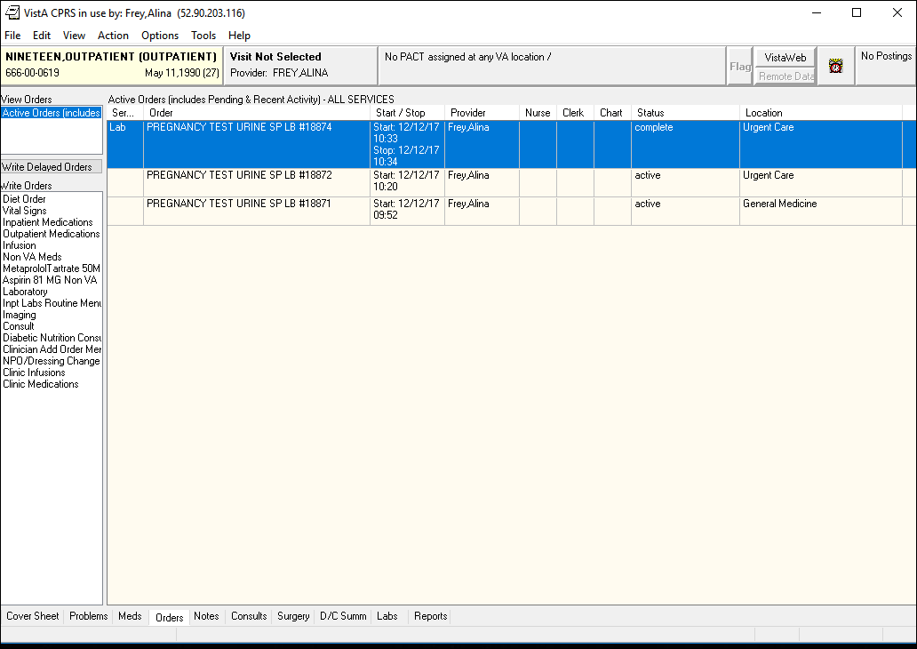

In order to make the Lab trigger a flag, the user needs to add a positive result **POS** to the lab. In order to do that, we need to use the menu **D ^XUS.**

GOLD>**S DUZ=1**

GOLD>**D ^XUS**

W E L C O M E TO

****** S I L V E R - E H M P V I S T A Account *******

Access privilege is based on specified need. As a user on this system,

YOU are responsible for complying with all security regulations

regarding access. YOU are not to share access codes with anyone or to

access accounts that do not pertain to YOUR job. YOU are responsible

for maintaining theintegrity, confidentiality, and security of all

information contained in this system.

USERs who use this system inappropriately will have their access

teminated and removed from the system.

VIEWing this message indicates that YOU agree with the terms of system

use.

MISUSE of this system constitutes a Federal Crime.

********************************************

>>>> CPRS and VITALS are installed in this account <<<<<

>> CPRS GUI Client is 1.0.30.72 Patch OR*3.0*350 <<

>> VITALS GUI MANAGER is at Cliet Version 5.0.26 Patch GMRV*5.0*26<<<

>>>M O C H A 2.0 is disabled

*********************************************************

Volume set: ROU:CACHE UCI: GOLD Device: /dev/pts/0 (97.68.114.106)

ACCESS CODE: ***************

Good morning FREY,ALINA

You last signed on today at 09:53

ROLLOVER HAS NOT RUN. ACCESSIONING SHOULDN'T BE DONE NOW.

ROLLOVER HAS BEEN TASKED -- TRY ACCESSIONING LATER

1 Phlebotomy menu ...

2 Accessioning menu ...

3 Process data in lab menu ...

4 Quality control menu ...

5 Results menu ...

6 Information-help menu ...

7 Ward lab menu ...

8 Anatomic pathology ...

9 Blood bank ...

10 Microbiology menu ...

11 Supervisor menu ...

LSM Lab Shipping Menu ...

Select Laboratory DHCP Menu <TEST ACCOUNT> Option: **3** Process data in lab menu

EA Enter/verify data (auto instrument)

EL Enter/verify data (Load list)

EM Enter/verify/modify data (manual)

EW Enter/verify data (Work list)

GA Group verify (EA, EL, EW)

MP Misc. Processing Menu ...

Accession order then immediately enter data

Batch data entry (chem, hem, tox, etc.)

Build a load/work list

Bypass normal data entry

Download a load list to an Instrument.

Fast Bypass Data Entry/Verify

Lookup accession

Order/test status

Print a load/work list

Std/QC/Reps Manual Workload count

Unload Load/Work List

Select Process data in lab menu <TEST ACCOUNT> Option: **accession** order then imme

diately enter data

Select Performing Laboratory: CAMP MASTER// NY VAMC 500

Select Order number: **18874 (the lab order number circled above)**

NINETEEN,OUTPATIENT 666-00-0619 Requesting location: UC

Date/Time Ordered: 12/12/2017 10:33 By: FREY,ALINA

-Lab Order # 18874 Provider: FREY,ALINA

URINE

PREGNANCY TEST ROUTINE Requested (SEND PATIENT) for: 12/12/2017

Is this the correct order? Yes// YES

Collection Date@Time: //**t@10:33** (DEC 12, 2017@10:33:00)

ACCESSION: CH 1212 4 <L673460004>

PREGNANCY TEST URINE

Sample: URINE

Specimen: URINE

1 PREGNANCY TEST

NINETEEN,OUTPATIENT SSN: 666-00-0619 LOC: UC

Pat Info: Sex: FEMALE Age: 27yr as of Dec 12, 2017

Provider: FREY,ALINA Voice pager:

Phone: Digital pager:

ACCESSION: CH 1212 4 [L673460004]

12/12 10:33d

PREGNANCY TEST //**POS**

Select COMMENT:

(POS)

Select COMMENT:

NINETEEN,OUTPATIENT SSN: 666-00-0619 LOC: UC

Pat Info: Sex: FEMALE Age: 27yr as of Dec 12, 2017

Provider: FREY,ALINA Voice pager:

Phone: Digital pager:

ACCESSION: CH 1212 4 [L673460004]

12/12 10:33d

PREGNANCY TEST POS

COMMENTS:

SELECT ('E' to Edit, 'C' for Comments, 'W' Workload):**<enter>**

Approve for release by entering your initials: **AF**

EA Enter/verify data (auto instrument)

EL Enter/verify data (Load list)

EM Enter/verify/modify data (manual)

EW Enter/verify data (Work list)

GA Group verify (EA, EL, EW)

MP Misc. Processing Menu ...

Accession order then immediately enter data

Batch data entry (chem, hem, tox, etc.)

Build a load/work list

Bypass normal data entry

Download a load list to an Instrument.

Fast Bypass Data Entry/Verify

Lookup accession

Order/test status

Print a load/work list

Std/QC/Reps Manual Workload count

Unload Load/Work List

* 1. Configure Problems

The procedure below illustrates the steps to enable triggering, for a specific problem. For this example, the problem is: **Pregnancy test positive**.

1. Open a VistA session and complete the following:

VAH>**D Q^DI**

VA FileMan 22.0

Select OPTION: **1** **ENTER OR EDIT FILE ENTRIES**

INPUT TO WHAT FILE: **WEBM TRIGGER PROBLEMS**// EDIT WHICH FIELD: ALL//

**Note**: Enter the SNOWMED code.

Select WEBM TRIGGER PROBLEMS CODE: **250423000**

Searching for a ICD, (pointed-to by CODE) Searching for a SCT, (pointed-to by CODE) ??

A suitable term could not be found based on user input

Enter Term/Concept:**<ENTER>**

Searching for a ICD

Searching for a SCT

250423000 Pregnancy test positive 250423000 SCT Preferred Active Primary

...OK? Yes//**y** (**Yes**)

Are you adding 'Pregnancy test positive' as

a new WEBM TRIGGER PROBLEMS (the 3RD)? No// **y** (**Yes**) INACTIVE:

Select PATIENT:

1. In CPRS, perform a search of the problem that will be used (Pregnancy test positive in this case), and take note of the code (SNOWMED CT) associated with the problem.

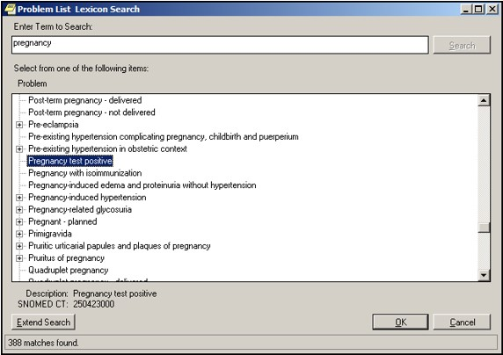

**Figure 10: Problem List to Search**

1. Users Setup
   1. Create Users

GOLD>S DUZ=1

GOLD>D Q^DI

VA FileMan 22.2

Select OPTION: 1 ENTER OR EDIT FILE ENTRIES

Input to what File: DEVICE// NEW PERSON (1476 entries)

EDIT WHICH FIELD: ALL//**NAME**

THEN EDIT FIELD: **ACCESS CODE** Want to edit ACCESS CODE (Y/N)

THEN EDIT FIELD: **VERIFY CODE**

THEN EDIT FIELD: **ELETRONIC SIGNATURE CODE**

Select NEW PERSON NAME: STEPHENS,JOSH

Are you adding 'STEPHENS,JOSH' as a new NEW PERSON (the 1477TH)? No// Y (Yes)

Checking SOUNDEX for matches.

No matches found.

NEW PERSON CITY: INDIAN HARBOUR BEACH

NEW PERSON STATE: FLORIDA

NEW PERSON INITIAL: JS

NEW PERSON MAIL CODE: 32937

Want to edit ACCESS CODE (Y/N): Y

Enter a new ACCESS CODE <Hidden>: ******

Please re-type the new code to show that I have it right: ******

OK, Access code has been changed!

The VERIFY CODE has been deleted as a security measure.

You will need to enter a new VERIFY code so the user can sign-on.

Select NEW PERSON NAME: LORD,BRIAN

Are you adding 'LORD,BRIAN' as a new NEW PERSON (the 1478TH)? No// Y (Yes)

Checking SOUNDEX for matches.

No matches found.

NEW PERSON CITY: DURHAM

NEW PERSON STATE: NC NORTH CAROLINA

NEW PERSON INITIAL: BL

NEW PERSON MAIL CODE: 27711

Want to edit ACCESS CODE (Y/N): Y

Enter a new ACCESS CODE <Hidden>: ******

Please re-type the new code to show that I have it right: ******

OK, Access code has been changed!

The VERIFY CODE has been deleted as a security measure.

You will need to enter a new VERIFY code so the user can sign-on.

Select NEW PERSON NAME: FREY,ALINA

Are you adding 'FREY,ALINA' as a new NEW PERSON (the 1479TH)? No// Y (Yes)

Checking SOUNDEX for matches.

No matches found.

NEW PERSON CITY: INDIAN HARBOUR BEACH

NEW PERSON STATE: FLORIDA

NEW PERSON INITIAL: AF

NEW PERSON MAIL CODE: 32937

Want to edit ACCESS CODE (Y/N): Y

Enter a new ACCESS CODE <Hidden>: ******

Please re-type the new code to show that I have it right: ******

OK, Access code has been changed!

The VERIFY CODE has been deleted as a security measure.

You will need to enter a new VERIFY code so the user can sign-on.

Select NEW PERSON NAME: WALTERS,SCOTTY

Are you adding 'WALTERS,SCOTTY' as a new NEW PERSON (the 1479TH)? No// Y (Yes)

Checking SOUNDEX for matches.

No matches found.

NEW PERSON CITY: INDIAN HARBOUR BEACH

NEW PERSON STATE: FLORIDA

NEW PERSON INITIAL: SW

NEW PERSON MAIL CODE: 32937

Want to edit ACCESS CODE (Y/N): Y

Enter a new ACCESS CODE <Hidden>: ******

Please re-type the new code to show that I have it right: ******

OK, Access code has been changed!

The VERIFY CODE has been deleted as a security measure.

You will need to enter a new VERIFY code so the user can sign-on.

Select NEW PERSON NAME: ^

* 1. Add Verify Code for the created users

Select OPTION: **1** ENTER OR EDIT FILE ENTRIES

Input to what File: **NEW PERSON**// (1479 entries)

EDIT WHICH FIELD: ALL// **VERIFY**

1 VERIFY CODE Want to edit VERIFY CODE (Y/N)

2 VERIFY CODE never expires

CHOOSE 1-2: 1 Want to edit VERIFY CODE (Y/N)

THEN EDIT FIELD:

Select NEW PERSON NAME: **JS**

1 JS PROVIDER,TWOHUNDREDTHIRTYNINE JS 10BA1/ADP Physician

2 JS PROVIDER,FIVEHUNDREDFOUR JS 10BA1/ADP Physician

3 JS STEPHENS,JOSH INDIAN HARBOUR BEACH FLORIDA JS 32937

4 JSH PROGRAMMER,FOURTEEN JSH 10BA1/ADP COMPUTER SPECIALIST

5 JSR LABTECH,SPECIAL JSR COMPUTER SPECIALIST

CHOOSE 1-5: 3 STEPHENS,JOSH INDIAN HARBOUR BEACH FLORIDA JS 32937

Want to edit VERIFY CODE (Y/N): **Y**

Enter a new VERIFY CODE: ********

Please re-type the new code to show that I have it right: ********

OK, Verify code has been changed!

Select NEW PERSON NAME: **frey** FREY,ALINA INDIAN HARBOUR BEACH FLORIDA AF 32937

Want to edit VERIFY CODE (Y/N): **y**

Enter a new VERIFY CODE: ********

Please re-type the new code to show that I have it right: ********

OK, Verify code has been changed!

Select NEW PERSON NAME: **lord** LORD,BRIAN DURHAM NORTH CAROLINA BL 27711

Want to edit VERIFY CODE (Y/N): y

Enter a new VERIFY CODE: ********

Please re-type the new code to show that I have it right: ********

OK, Verify code has been changed!

Select NEW PERSON NAME: **walters** WALTERS,SCOTTY INDIAN HARBOUR BEACH FLORIDA SW 32937

Want to edit VERIFY CODE (Y/N): y

Enter a new VERIFY CODE: ********

Please re-type the new code to show that I have it right: ********

OK, Verify code has been changed!

Select NEW PERSON NAME: ^

Select OPTION: ^

* 1. Allocate keys to the new users

GOLD>S DUZ=1

GOLD>S $P(^VA(200,DUZ,0),"^",4)="@"

GOLD>D ^XUP

Setting up programmer environment

This is a TEST account.

Terminal Type set to: C-VT100

You have 166 new messages.

Select OPTION NAME: **XUMAINT** Menu Management

Edit options

Key Management ...

Secure Menu Delegation ...

Restrict Availability of Options

Option Access By User

List Options by Parents and Use

Fix Option File Pointers

Help Processor ...

OPED Screen-based Option Editor

Display Menus and Options ...

Menu Rebuild Menu ...

Out-Of-Order Set Management ...

See if a User Has Access to a Particular Option

Show Users with a Selected primary Menu

You have PENDING ALERTS

Enter "VA to jump to VIEW ALERTS option

You've got PRIORITY mail!

Select Menu Management <TEST ACCOUNT> Option: **KEY** Management

Allocation of Security Keys

De-allocation of Security Keys

Enter/Edit of Security Keys

All the Keys a User Needs

Change user's allocated keys to delegated keys

Delegate keys

Keys For a Given Menu Tree

List users holding a certain key

Remove delegated keys

Show the keys of a particular user

You have PENDING ALERTS

Enter "VA to jump to VIEW ALERTS option

You've got PRIORITY mail!

Select Key Management <TEST ACCOUNT> Option: **ALL**

1 All the Keys a User Needs

2 Allocation of Security Keys

CHOOSE 1-2: **2** Allocation of Security Keys

Allocate key: **XUMGR**

Another key: **XUPROG**

1 XUPROG

2 XUPROGMODE

CHOOSE 1-2: **1** XUPROG

Another key: **XUPROGMODE**

Another key: **XMMGR**

Another key: **XUSPF200**

**Same for these keys:**

Another key: **CPRS TAB**

Another key: **WEBM DDCS CONFIG**

Holder of key: **STEPHENS**,JOSH INDIAN HARBOUR BEACH FLORIDA JS 3

2937

Another holder: **LORD**,BRIAN DURHAM NORTH CAROLINA BL 27711

Another holder: **FREY**,ALINA INDIAN HARBOUR BEACH FLORIDA AF 329

37

Another holder: **WALTERS**,SCOTTY INDIAN HARBOUR BEACH FLORIDA SW

32937

You've selected the following keys:

C

You've selected the following holders:

STEPHENS,JOSH LORD,BRIAN FREY,ALINA

You are allocating keys. Do you wish to proceed? YES//

XUPROG being assigned to:

STEPHENS,JOSH

LORD,BRIAN

FREY,ALINA

WALTERS,SCOTTY

XUMGR being assigned to:

STEPHENS,JOSH

LORD,BRIAN

FREY,ALINA

WALTERS,SCOTTY

XUPROGMODE being assigned to:

STEPHENS,JOSH

LORD,BRIAN

FREY,ALINA

WALTERS,SCOTTY

XMMGR being assigned to:

STEPHENS,JOSH

LORD,BRIAN

FREY,ALINA

WALTERS,SCOTTY

XUSPF200 being assigned to:

STEPHENS,JOSH

LORD,BRIAN

FREY,ALINA

WALTERS,SCOTTY

Allocation of Security Keys

De-allocation of Security Keys

Enter/Edit of Security Keys

All the Keys a User Needs

Change user's allocated keys to delegated keys

Delegate keys

Keys For a Given Menu Tree

List users holding a certain key

Remove delegated keys

Show the keys of a particular user

You have PENDING ALERTS

Enter "VA to jump to VIEW ALERTS option

You've got PRIORITY mail!

Select Key Management <TEST ACCOUNT> Option: **^**

Edit options

Key Management ...

Secure Menu Delegation ...

Restrict Availability of Options

Option Access By User

List Options by Parents and Use

Fix Option File Pointers

Help Processor ...

OPED Screen-based Option Editor

Display Menus and Options ...

Menu Rebuild Menu ...

Out-Of-Order Set Management ...

See if a User Has Access to a Particular Option

Show Users with a Selected primary Menu

You have PENDING ALERTS

Enter "VA to jump to VIEW ALERTS option

You've got PRIORITY mail!

Select Menu Management <TEST ACCOUNT> Option: **^**

* 1. Add Primary and Secondary menus to the new users

GOLD>**S DUZ=1**

GOLD>**D ^XUP**

Setting up programmer environment

This is a TEST account.

Terminal Type set to: C-VT100

You have 166 new messages.

Select OPTION NAME: **XUSERED**

1 XUSEREDIT Edit an Existing User

2 XUSEREDITSELF Edit User Characteristics

CHOOSE 1-2: **1** EVXUSEREDIT Edit an Existing User

Edit an Existing User

Select NEW PERSON NAME: **STEPHENS**,JOSH INDIAN HARBOUR BEACH FLORIDA

JS 32937

Edit an Existing User

NAME: **STEPHENS,JOSH** Page 1 of 5

_______________________________________________________________________________

NAME... STEPHENS,JOSH INITIAL: JS

TITLE: NICK NAME: **BOSS**

SSN**:<MUST ENTER 9 DIGIT>** DOB:

DEGREE: MAIL CODE: **32937**

DISUSER: TERMINATION DATE:

Termination Reason:

PRIMARY MENU OPTION: **EVE**

Select SECONDARY MENU OPTIONS: **OR CPRS GUI CHART**

**NOTE: When editing SECONDARY MENU OPTIONS field, enter the following values:**

**WEBM DDCS CONTEXT**

**WEBM GUI CONTEXT**

**WEBM MAIN**

Want to edit ACCESS CODE (Y/N): FILE MANAGER ACCESS CODE:

Want to edit VERIFY CODE (Y/N):

Select DIVISION:

SERVICE/SECTION: **INFORMATION RESOURCE MGMT**

_______________________________________________________________________________

Exit Save Next Page Previous Page Refresh Quit

Enter a COMMAND, or "^" followed by the CAPTION of a FIELD to jump to.

COMMAND: NEXT Press <PF1>H for help Insert

Edit an Existing User

NAME: STEPHENS,JOSH Page 2 of 5

_______________________________________________________________________________

NETWORK USERNAME:

TIMED READ (# OF SECONDS): **1800**

MULTIPLE SIGN-ON: **ALLOWED** MULTIPLE SIGN-ON LIMIT: **5**

ASK DEVICE TYPE AT SIGN-ON: AUTO MENU:

PROHIBITED TIMES FOR SIGN-ON: TYPE-AHEAD:

AUTO SIGN-ON:

Preferred Editor: SCREEN EDITOR - VA FILEMAN

ALLOWED TO USE SPOOLER: PAC:

CAN MAKE INTO A MAIL MESSAGE:

FILE RANGE:

ALWAYS SHOW SECONDARIES:

_______________________________________________________________________________

Exit Save Next Page Previous Page Refresh Quit

Enter a COMMAND, or "^" followed by the CAPTION of a FIELD to jump to.

GOLD>

Do the same for the other users.

8.4.1. Modify the web.config

**Find web.config in the top level of the code installation, root installation directory.**

**Change AppContext key to the name of the new namespace to match this**

**<add key="AppContext" value="WEBM GUI CONTEXT" />**

* 1. Assign SECURITY KEY

GOLD>**S DUZ=1**

GOLD>**D ^XUP**

Setting up programmer environment

This is a TEST account.

Terminal Type set to: C-VT100

You have 166 new messages.

Select OPTION NAME: **XUMAINT** Menu Management

Edit options

Key Management ...

Secure Menu Delegation ...

Restrict Availability of Options

Option Access By User

List Options by Parents and Use

Fix Option File Pointers

Help Processor ...

OPED Screen-based Option Editor

Display Menus and Options ...

Menu Rebuild Menu ...

Out-Of-Order Set Management ...

See if a User Has Access to a Particular Option

Show Users with a Selected primary Menu

You have PENDING ALERTS

Enter "VA to jump to VIEW ALERTS option

You've got PRIORITY mail!

Select Menu Management <TEST ACCOUNT> Option: **KEY** Management

Allocation of Security Keys

De-allocation of Security Keys

Enter/Edit of Security Keys

All the Keys a User Needs

Change user's allocated keys to delegated keys

Delegate keys

Keys For a Given Menu Tree

List users holding a certain key

Remove delegated keys

Show the keys of a particular user

You have PENDING ALERTS

Enter "VA to jump to VIEW ALERTS option

You've got PRIORITY mail!

Select Key Management <TEST ACCOUNT> Option: **ALLOCATION** of Security Keys

Allocate key: **WEBM DDCS CONFIG**

Another key:

Holder of key: **STEPHENS**,JOSH INDIAN HARBOUR BEACH FLORIDA JS 3

2937

Another holder: **LORD**,BRIAN DURHAM NORTH CAROLINA BL 27711

Another holder: **FREY**,ALINA INDIAN HARBOUR BEACH FLORIDA AF 329

37

Another holder:

You've selected the following keys:

WEBM DDCS CONFIG

You've selected the following holders:

STEPHENS,JOSH LORD,BRIAN FREY,ALINA WALTERS,SCOTTY

You are allocating keys. Do you wish to proceed? YES// **YES**

WEBM DDCS CONFIG being assigned to:

STEPHENS,JOSH

LORD,BRIAN

FREY,ALINA

WALTERS,SCOTTY

Allocation of Security Keys

De-allocation of Security Keys

Enter/Edit of Security Keys

All the Keys a User Needs

Change user's allocated keys to delegated keys

Delegate keys

Keys For a Given Menu Tree

List users holding a certain key

Remove delegated keys

Show the keys of a particular user

You have PENDING ALERTS

Enter "VA to jump to VIEW ALERTS option

You've got PRIORITY mail!

Select Key Management <TEST ACCOUNT> Option:

* 1. Assign CPRS TAB

VISTA>D Q^DI

VA FileMan 22.0

Select OPTION: 1  ENTER OR EDIT FILE ENTRIES

INPUT TO WHAT FILE: DEVICES// NEW PERSON

EDIT WHICH FIELD: ALL// KEYS

     1   KEYS    (multiple)

     2   KEYSTROKES FROM LM WP

   CHOOSE 1-2: 1  KEYS  (multiple)

           EDIT WHICH KEYS SUB-FIELD: ALL// (Hit enter here)

THEN EDIT FIELD: CPRS TAB    (multiple)

   EDIT WHICH CPRS TAB SUB-FIELD: ALL// (Hit enter here)

THEN EDIT FIELD: RESTRICT PATIENT SELECTION

 THEN EDIT FIELD: (Hit enter here)

Select NEW PERSON NAME: SM  MANAGER,SYSTEM     SM          Clinical Coordinator

Select KEY: // ORES

         ...OK? Yes//   (Yes)

  KEY: ORES//

  REVIEW DATE:

Select KEY: // PROVIDER

         ...OK? Yes//   (Yes)

  KEY: PROVIDER//

  REVIEW DATE:

Select KEY:  (Hit enter here)

Select CPRS TAB: // RPT

     EFFECTIVE DATE:// MAY 1,2003

     EXPIRATION DATE:// MAY 1,2020

  CPRS TAB: RPT// COR       CPRS GUI "core" tabs.

   Are you adding 'RPT' as a new CPRS TAB (the 2ND for this NEW PERSON)? No// Y

     EFFECTIVE DATE:// MAY 1,2003

     EXPIRATION DATE:// MAY 1,2020

Select CPRS TAB: (Hit enter here)

RESTRICT PATIENT SELECTION:// No  NO

Select NEW PERSON NAME:(Hit enter here)

Select OPTION:(Hit enter here)

VISTA>

1.      At the VISTA prompt, enter D ^ZTMB to start TaskMan

2.      Then start BROKER listening on port 9210  by entering the following at the VISTA prompt: D STRT^XWBTCP(9210)  You may choose another port – OpenVista uses 9200.

USER>**D ^%CD**

Namespace: VISTA

You're in namespace VISTA

Default directory is c:\cachesys\mgr\vista\

VISTA>**D ^ZTMB**

VISTA>**D STRT^XWBTCP(9210)**

Start TCP Listener...

Checking if TCP Listener has started...

TCP Listener started successfully.

VISTA>

* 1. Assign Electronic Signature

GOLD>S DUZ=1

GOLD>D Q^DI

VA FileMan 22.2

Select OPTION: 1 ENTER OR EDIT FILE ENTRIES

Input to what File: NEW PERSON// new perSON (1478 entries)

EDIT WHICH FIELD: ALL// electroNIC SIGNATURE CODE

THEN EDIT FIELD:

Select NEW PERSON NAME: frey FREY,ALINA MELBOURNE FLORIDA AF 32937

ELECTRONIC SIGNATURE CODE: af1234!!

Select NEW PERSON NAME: steph STEPHENS,JOSH MELBOURNE FLORIDA JS 32937

ELECTRONIC SIGNATURE CODE: js1234!!

Select NEW PERSON NAME:

1. Configure IIS Server
2. Use Remote Desktop to connect to the Windows Server 2012 machine.
3. On the Windows Server 2012 machine, create a **WebDeploy** folder under **C:\inetpub.** Windows Server 2012 should already have the **inetpub** located under the C: drive, if not, create it.

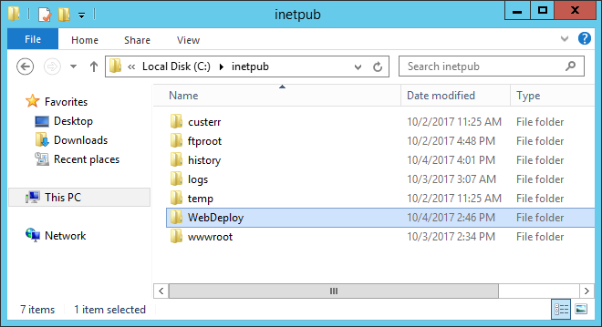

1. Click on Start > Server Manager to open server manager.
2. From Server Manager, click the IIS tab and double click the IIS Instance Name. Alternatively, click the Windows button and type “IIS Manager”

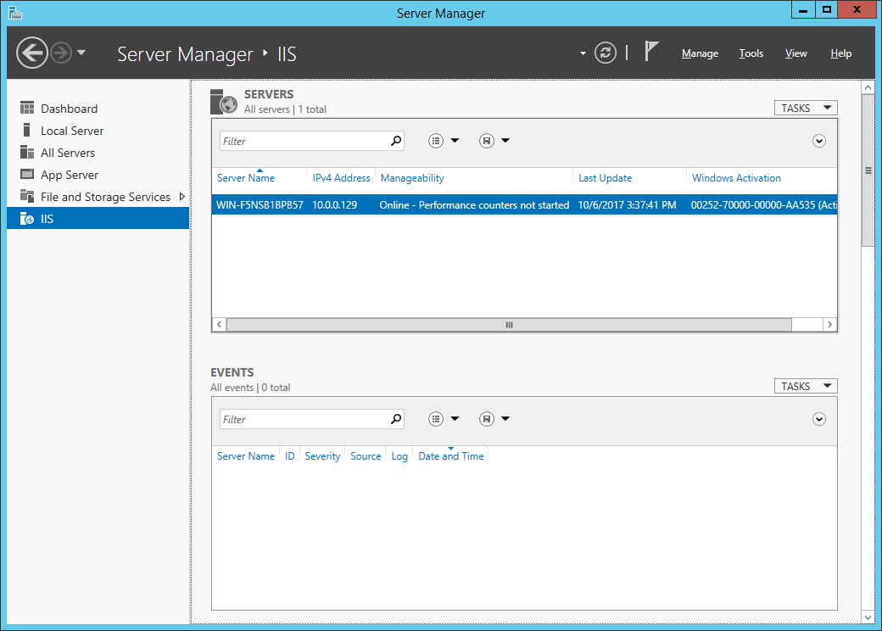

1. In IIS Manager, right click “Sites” and select “Add Website…”

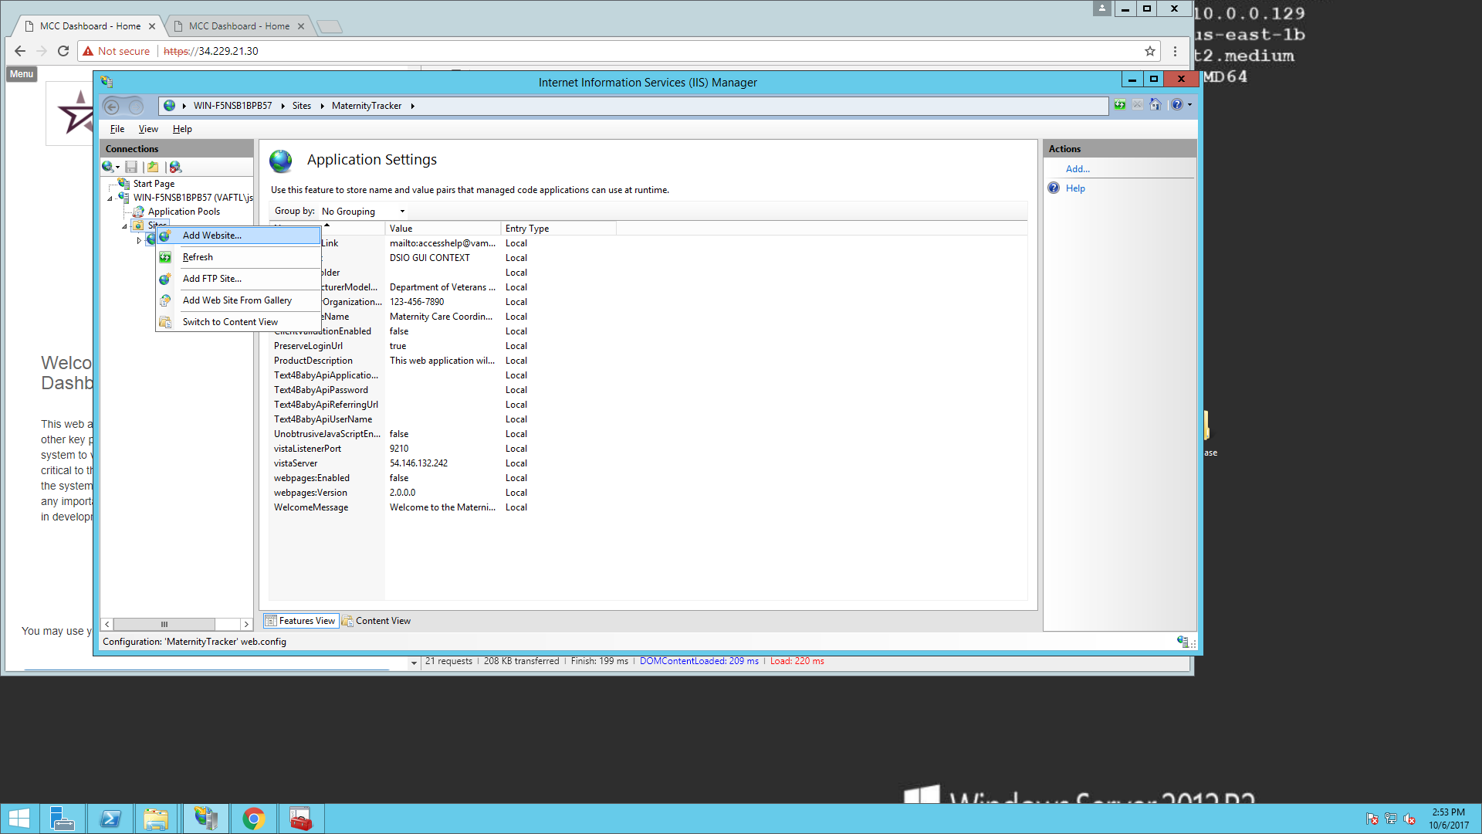

1. Enter “MaternityTracker” as the Site name. Select “C:\inetpub\WebDeploy” as the Physical Path. Select “OK”.

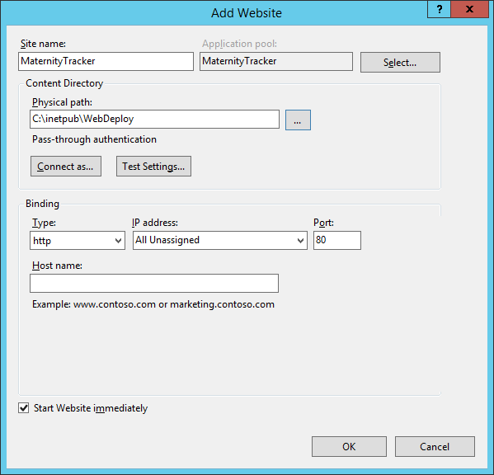

1. MaternityTracker site will be added to the Sites.
2. Right click the “MaternityTracker” website, go to “Deploy” -> “Configure Web Deploy Publishing…”

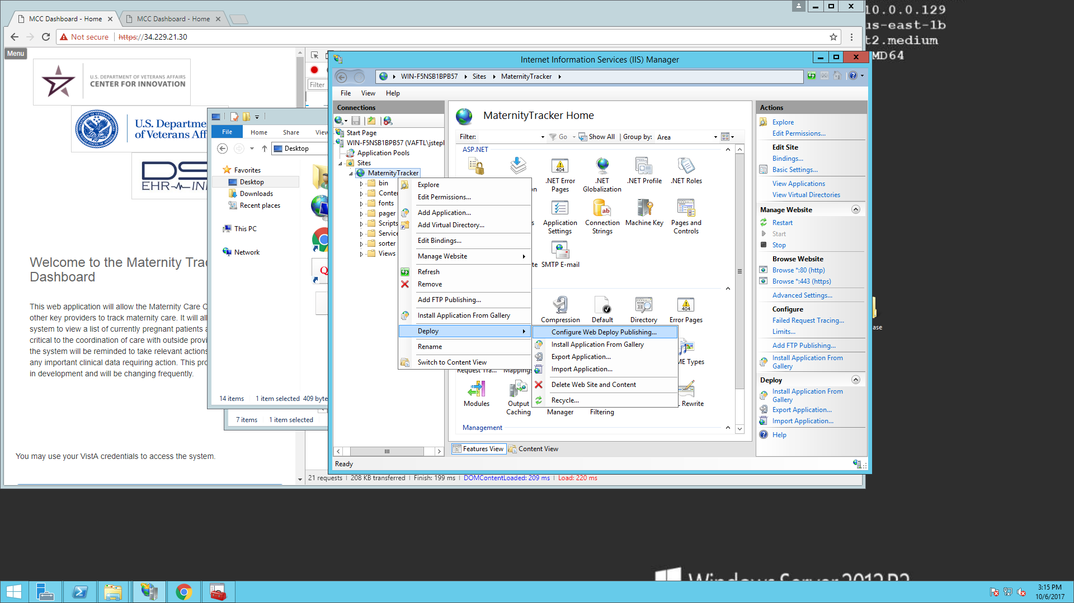

1. Enter your fully qualified username, enter the IP Address of the IIS server, and the location at which you would like the publishing configuration file saved.

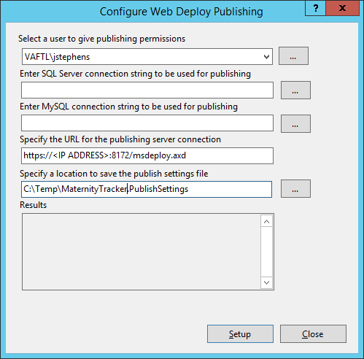

1. Copy the file created in the previous step (**C:\Temp\MaternityTracker.PublishSettings**) to the machine running Visual Studio. Remote Desktop allows copying files from the remote machine to local machine.
2. Open the file in a text editor and ensure the following fields are appropriate:

<?xml version="1.0" encoding="utf-8"?>

<publishData>

<publishProfile

publishUrl="https://**<IIS SERVER IP>:**8172/msdeploy.axd"

msdeploySite="MCCDashboardTest"

destinationAppUrl="http://**<IIS SERVER IP>:<PORT>/**MCCDashboardTest"

mySQLDBConnectionString=""

SQLServerDBConnectionString=""

profileName="Default Settings"

publishMethod="MSDeploy"

userName="**<FQ USERNAME>**" />

</publishData>

1. On the IIS Server, ensure the Maternity Tracker Website is selected and click “Bindings...” under the Actions pane on the right.

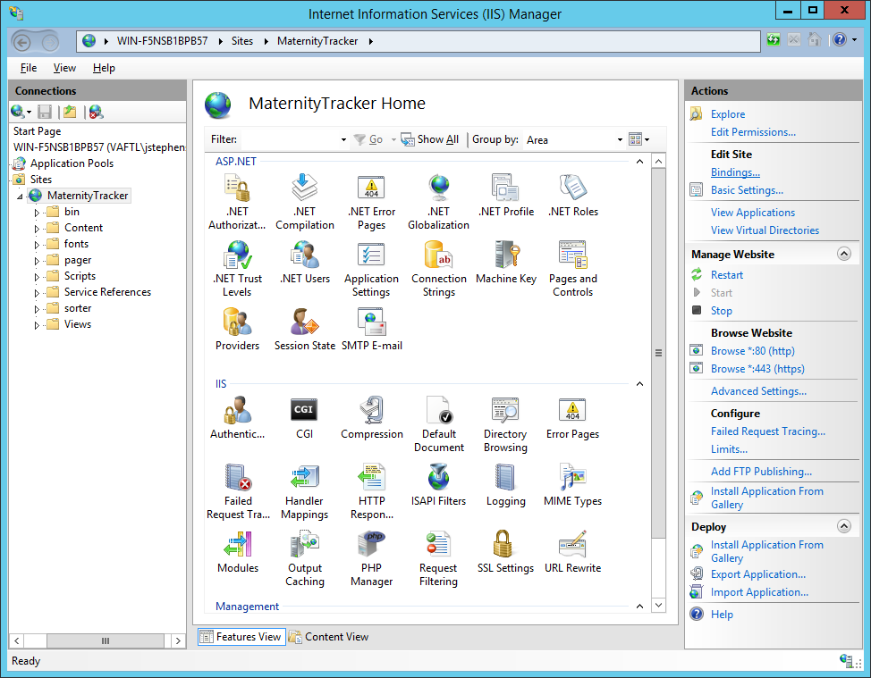

1. Here you will find all the port and protocol bindings for the website. Click “Add...” to add the https protocol and port.

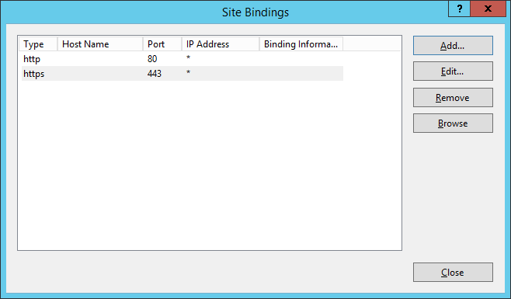

1. Change the Type to https, the port should automatically update to 443. Leave Host name blank. Select server’s SSL certificate. If you have a signed certificate from a certificate authority service, you would select that here.

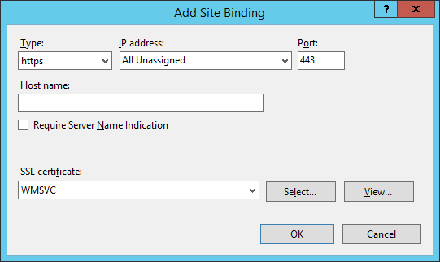

1. Deploy Maternity Tracker Dashboard to IIS
2. On the local machine, open Visual Studio, and the Maternity-Tracker project.
3. In Visual Studio, right click **va.gov.artemis.ui** and click “Publish…”:

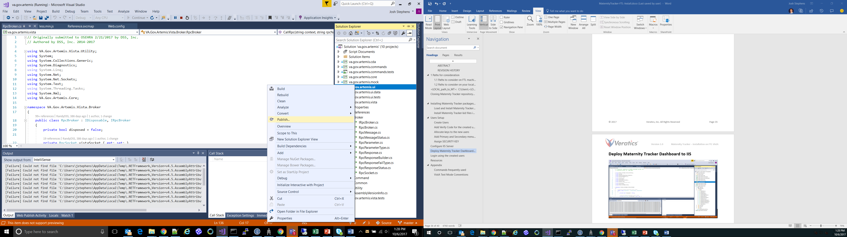

1. With the Publish pane selected on the left, make sure that the select **Import profile**. If a profile is already selected, click on the link **Create new profile**. Select the profile publishing file you generated from IIS in the last section.

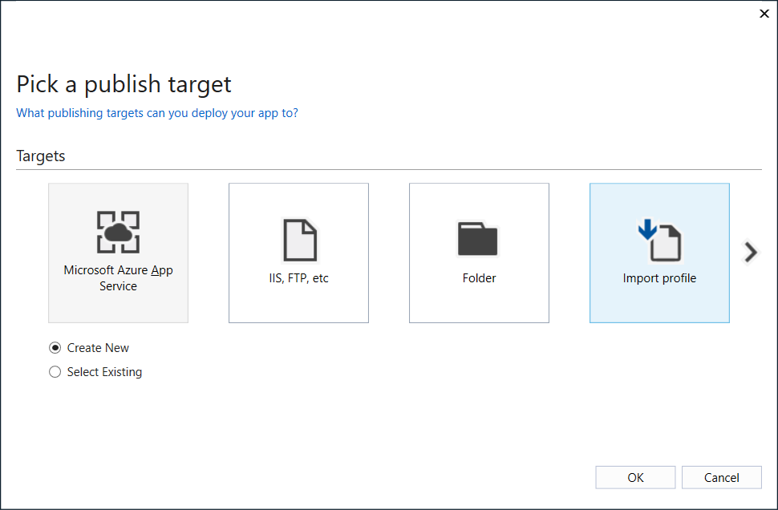

1. Ensure all information in the Summary pane is correct and click “Publish”.

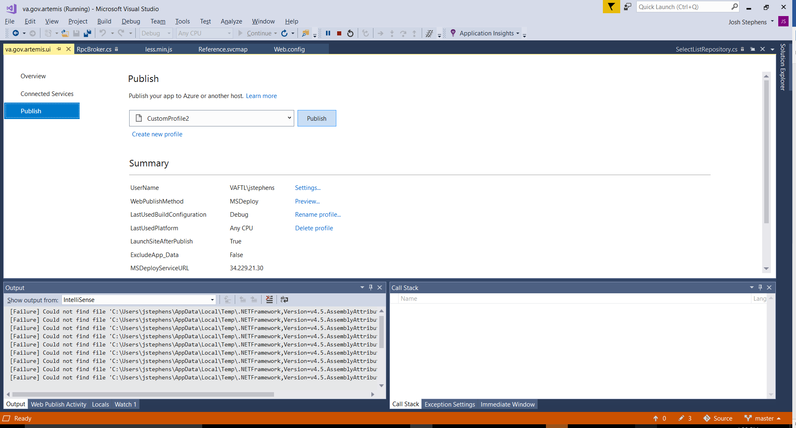

1. When prompted, enter your credentials for the destination IIS server

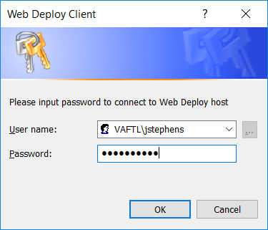

1. Ensure that the publish was successful

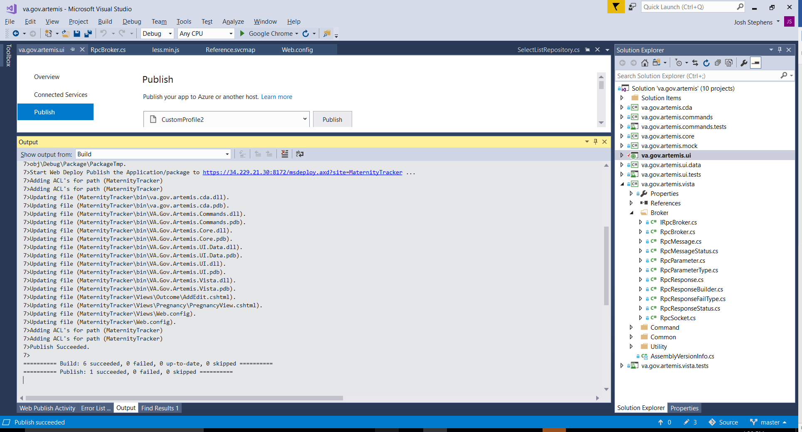

1. On the IIS Server, click on the website name created in the previous section and double click “Application Settings”

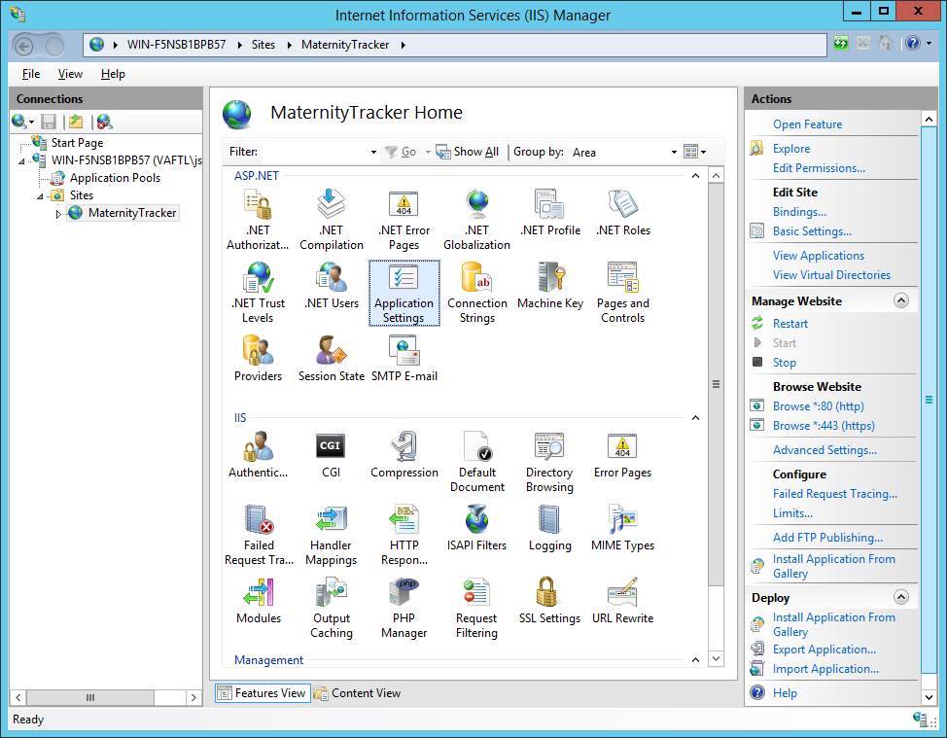

1. Enter the values of the Vista Server and RPC Port configurations in the corresponding properties.

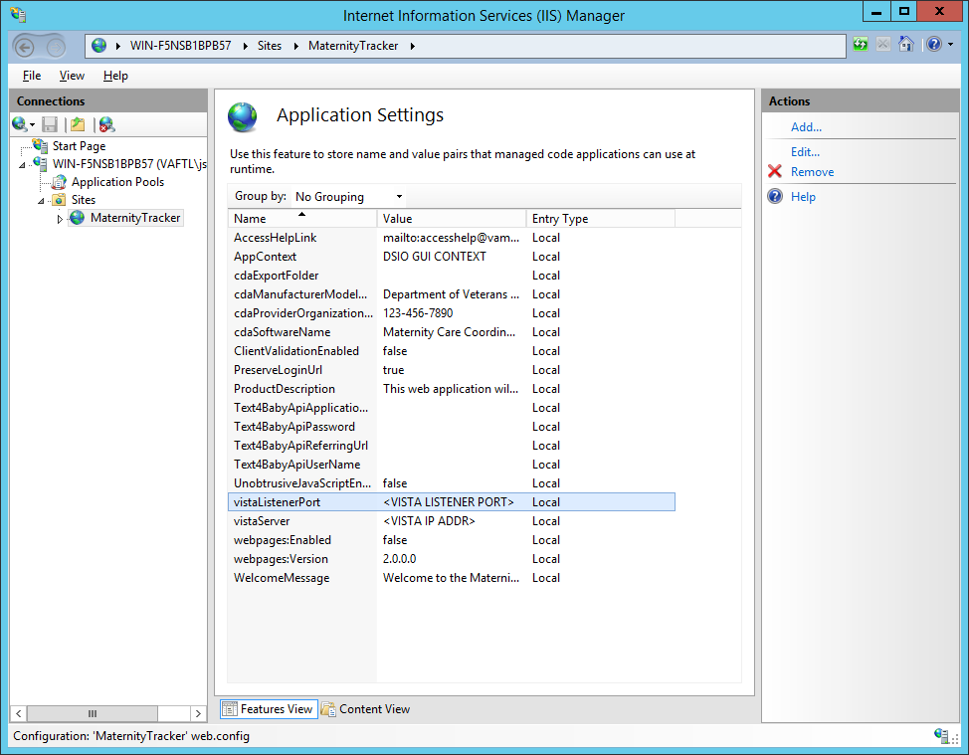

1. Login using the created users

After the users are created as discussed is Chapter 8 Users Setup, and the build is deployed as specified in Chapter 10 Deploy Maternity Tracker Dashboard to IIS, you can login in the Maternity Tracker Dashboard at the following link:

**https://<ip_address_of_windows_server>/**

The Dashboard should display as follows:

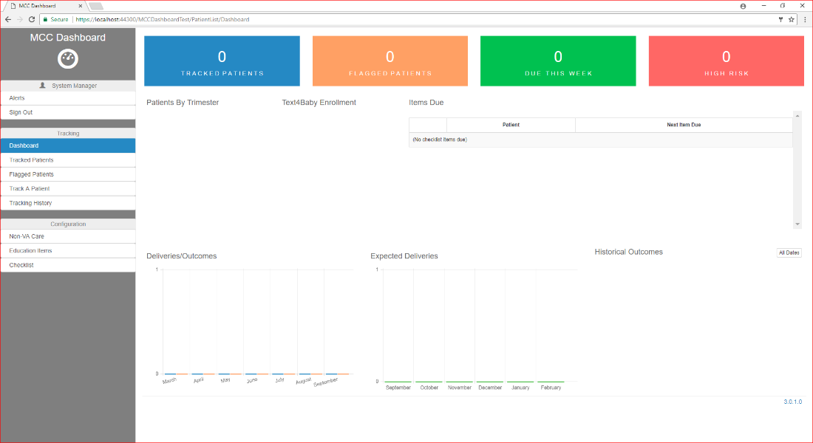

1. Resources
2. <https://github.com/veratics/Maternity-Tracker>
3. <https://github.com/Veratics/Maternity-Tracker/blob/master/README.md>
4. <https://github.com/OSEHRA/VistA/blob/master/Documentation/README.rst#cache>
5. <https://www.osehra.org/content/how-setup-osehra-vista-development-virtual-machine-vm-0>
6. <https://github.com/OSEHRA/VistA/blob/master/Documentation/InstallCache.rst>
7. <https://github.com/OSEHRA/VistA/blob/master/Documentation/ObtainingVistAMCode.rst>
8. <https://github.com/OSEHRA/VistA/blob/master/Documentation/PrepareMComponents.rst>
9. <https://github.com/OSEHRA/VistA/blob/master/Documentation/ImportCache.rst>
10. <https://github.com/OSEHRA/VistA/blob/master/Documentation/ConfigureCache.rst>
11. <http://www.hardhats.org/projects/New/InitializeVistA.html>
12. <http://www.hardhats.org/projects/Old/VistA_Install/CPRSStart12.html>
13. <http://www.hardhats.org/projects/VistA_Install/Vista_Install.html>
14. <http://www.vistapedia.com/index.php/VISTA_XWB_Broker_Troubleshooting>
15. <https://download.intersystems.com/download/download.csp>
16. Appendix
    1. Commands frequently used

S DUZ=.5 – S is a shortcut for SET, DUZ means user number; .5 is a user that is always present on VistA systems.

D ^XUP – D is a shortcut for DO, ^XUP is the name of the routine. ^XUP is the programmer mode menu runner.

D Q^DI – Do starting from Label Q in Routine DI. Q^DI is how to enter Fileman.

D ^ZTMGRSET – Defines VistA global variables and saves system wide M routines.

D ^DINIT – Initialize Fileman to set your domain name and number and Operating System

D ^ZUSET – Choose the correct version of ZU

D ^ZTMB – Start Taskman

D CHECK^XWBTCPMT - Check RPC Broker

D CALL^XWBTCPMT - Call RPC Broker

D STRT^XWBTCP - Start RPC Broker

D THIS^%SS - Display the running processes

; - A semicolon is the comment character. M, like C, was written to replace assembly.

* 1. VistA Text Mode Conventions

// – means that the preceding text is the default. If you press enter, you will accept it.

'Replace' – means that the existing text is long and you can edit it.

... – means that you will replace the entire thing;

END – appends to the end. You can also use ... to signify a range between two elements in the existing text. You can also enter a unique segment of the text, press enter, and at the with prompt put in what you want to replace that bit of text with. If you don't type anything in, it deletes that part of the text.

@ – deletes an item.

^ – usually lets you quit what you are in the middle of.

^FIELD NAME – lets you jump to a field while editing other fields. You may be blocked depending on what the programmer decides you are allowed to do.

? – Short Help. Typically it tells you that you need to type a number or text.

?? – More Help. Should tell you what the field you are filling does. In the menu system, show all menus with what security keys they need.

??? – In the menu system, display help for each immediate submenu.

???? – In the menu system, display help for current menu.

<enter> key – is the main navigation key in VistA. Typing it after an entry enters that entry; typing when nothing is entered will move you forward or up, depending on the context.

Select <item> – Whenever you see select, you can select or add an item; after that, you can edit it.

Spacebar <enter> – Most of the time, VistA remembers the last entry you made for a particular field. To make the same entry again, do spacebar enter.